
Leveraging Explainable AI to Support Incident Response
Decision-Making in Security Operations Centers
XAI-SOC: An Explainable AI System for SOC Alert Triage
Final Dissertation — Milestone 3: Final Written Dissertation Document
Module Code: COMP70045-2025-SPG3-2026-SPG1
Student Full Name: M Mukit Hasan
Student ID: 25021995
Email: h021995p@student.staffs.ac.uk
Project Supervisor: Elhadj Benkhelifa

Table of Contents
Abstract 4
Chapter 1: Introduction 5-7
1.1 Background and Motivation 5
1.2 The XAI-SOC System 6
1.3 Research Question and Hypothesis 6
1.4 Aim and Objectives 6-7
1.5 Structure of the Dissertation 7
Chapter 2: Literature Review 8-21
2.1 The Growing Reliance on AI in Security Operations Centers 8
2.2 Security Operations Centers and the Incident Response Lifecycle. 9
2.3 AI/ML powered SOC Automation 9-10
2.4 Interpretability Gap: Alert Fatigue and Black-Box Problem 10
2.5 Explainable AI: Concepts and Techniques 10-14
2.5.1 Defining Explainability in Security Contexts 10-11
2.5.2 After-training model independent tools: SHAP and LIME 11-12
2.5.3 Intrinsically Interpretable Models and Attention Mechanisms 12
2.5.4 Comparative Overview of XAI Techniques 13-14
2.6 Applications of XAI in Incident Response Decision Making 14
2.6.1 Alert Triage and Prioritisation 14
2.6.2 Threat Intelligence and Forensic Root-Cause Analysis 15
2.6.3 Human-AI Interaction and Analyst Confidence 15-17
2.6.4 Conversational and LLM-based Explainability 18
2.7 Synthesis of Findings Across the Literature: 18-19
2.8 Discussion and Implications for Practice 19-20
2.9 Reviewed literature: Datasets and Evaluation practices 20-22
Analysis of the Problem and Proposed Improvement 22
Chapter 3: Research Methods 23-26
3.1 Overall Methodological Approach 23
3.2 Data and Modelling Methodology 23
3.3 Explainability Methodology 24
3.4 Evaluation Methodology Used in This Dissertation 24-25
3.5 Planned Controlled User Study Methodology 25-26
Chapter 4: Design of the Artefact 25
4.1 Overview of System Architecture 26
4.2 Data Pipeline Design 26-28
4.3 Model Comparison and Selection Design 29
4.4 Explainability Design 29
4.5 Backend Deployment Design Decision: Decision Tree over K-Nearest Neighbours 29
4.6 Artefact Schema Design 30
4.7 Streamlit Dashboard Design 30
4.8 Reproducibility Design 30
chapter 5: Implementation, Testing and Validation of the Artefact 31
Implementation Environment and Data Acquisition 32
Schema Harmonisation and Merging 32
Data-Quality Issues Encountered and Resolved 33
Preprocessing, Split and Class-Imbalance Handling 33
Multi-Model Implementation and Results 34
Explainability Implementation for the Deployed Model 34-38
Backend Artefact Export 38
Streamlit Dashboard Validation 38-42
Critical Evaluation 45-46
Model Comparison: Accuracy versus Macro F1 45
Why Decision Tree, Not K-Nearest Neighbours, Was Deployed 46-47
Per-Class Performance of the Deployed Decision Tree Model 47-49
SHAP versus LIME: Do They Agree? 49
Strengths, Weaknesses and Alignment with Objectives 50-52
Chapter 6: Conclusions and Future Work 51-52
References 53-56

Abstract
Network intrusion detection systems powered by machine learning generate accurate alerts but remain opaque, eroding analyst trust and complicating forensic accountability within Security Operations Centre (SOC) workflows. This dissertation designs, implements, and critically evaluates XAI-SOC, an explainable AI system for SOC alert triage built on the merged CICIDS2017 and CSE-CIC-IDS2018 network-flow benchmarks. A reproducible harmonised pipeline resolves genuine data-quality defects in the raw benchmark files, trains and compares seven classifiers on a stratified 2.86-million-row dataset sampled at 15% of the combined benchmark for computational tractability, and selects among them using macro-averaged F1 to mitigate severe class imbalance. SHAP and LIME are integrated as complementary explanation methods, with the SHAP explainer strategy automatically selected based on model architecture. A central empirical finding is that the macro-F1-optimal model, K-Nearest Neighbours, requires over two hours to generate SHAP explanations for 100 alerts, making it impractical for real-time SOC deployment. The deployed artefact therefore uses the best-performing tree-based model, Decision Tree (accuracy: 98.11%, macro F1: 0.7325), which supports SHAP's exact TreeExplainer and produces near-instantaneous explanations. The model, scaler, label encoder, and explanation logic are encapsulated in a three-tab Streamlit dashboard supporting per-alert triage, global class-level explanations, and model performance transparency. Dashboard validation with real held-out DDoS, PortScan, and Bot flows confirmed correct classification with dual SHAP/LIME panels rendering instantly. A professional feedback survey (N = 27 cybersecurity practitioners and students) evaluated the dashboard's explanations: participants rated trust in SHAP/LIME explanations at a mean of 4.26/5 (SD = 0.71), clarity at 4.00/5 (SD = 0.83), confidence in triage decisions at 4.22/5 (SD = 0.70), and practical speed at 4.07/5 (SD = 0.78), all significantly above the neutral midpoint (all p < 0.001). SHAP was preferred by 77.8% of respondents. Key limitations include the 15% sampling strategy (full-scale revalidation remains future work), weak Infiltration class F1 (0.13) despite substantial test support, and an absence of a controlled within-subject user study. The dissertation contributes a concrete, empirically grounded demonstration that model selection for explainable SOC systems must treat explanation tractability as a first-class design constraint alongside predictive accuracy.

Chapter 1: Introduction

1.1 Background and Motivation
Security Security Operations Centres (SOCs) are the first point of contact for an organisation's cyber-defence strategy, managing to detect, prioritise and respond to an ever-expanding network of network security alerts (Charla, 2025; Agoro and Moore, 2024). In the last decade, it was observed that intrusion detection systems (IDS) based on the use of machine learning have played a pivotal role in tackling this challenge and ensemble classifiers and deep-learning models have consistently showcased nearly 100% accuracy in publicly available benchmarks like CICIDS2017 and CSE-CIC-IDS2018 (Akshay Kumaar et al., 2022). This apparent success, however, hides a practical issue – the models used to identify traffic as malicious are effectively black boxes. Without an analyst understanding the specific reason the model made its predictions, "this flow is malicious," triage time is drag, analysts' trust is broken, and compliance and forensic accountability in responding to incidents is hindered (Nyre-Yu et al., 2022; Safavi et al., 2025).
To escape this difficulty, explainable AI (XAI) approaches have been introduced, especially SHAP (Lundberg and Lee, 2017) and LIME (Ribeiro, Singh and Guestrin, 2016) which provide a means of attributing the actual prediction produced by a model to the input features that have made this possible, in a way that is comprehensible to an analyst and presented in addition to the alert. Like most of the literature reviewed in Chapter 2, Eriksson and Grov (2022) evaluated the explanations in the context of a SOC but not side-by-side on the same alerts; did not report the number of queries required to generate the explanations; and did not produce explanations that can be loaded into tooling similar to an operational SOC dashboard. This dissertation fills that combination of gaps.

1.2 The XAI-SOC System
In this dissertation, XAI-SOC, an explainable AI system for the triage of SOC alerts, is designed, implemented and evaluated. The system will use the benchmark CICIDS2017/CSE-CIC-IDS2018 network-flow and train and test seven classifiers, avoiding a pre-selected algorithm, and choose the appropriate classifiers using macro-averaged F1 to prevent the large majority of BENIGN of the dataset mask the performance of minority attack classes. SHAP and LIME are added as secondary explanations to each alert, and the entirety of the pipeline is then made into an interactive dashboard to be experienced by an analyst.
A key empirical takeaway of this thesis (as documented in detail in the Implementation, Validation and Critical Evaluation sections of this dissertation), is that the model which fares best by purely macro F1, KNN is impractical to explain even in anything resembling real time: SHAP's model-agnostic Permutation explainer took more than two hours to explain 100 test alerts for that model. The results of this discovery directly influenced the final design of the artefact: although an ensemble of models could be deployed at the end of the leaderboard, it makes little sense to deploy a model no matter if this is tree-based or not—in situations where we need to explain the reason for a prediction, it is obviously preferable to deploy the best-performing tree-based model (Decision Tree) which enables SHAP exact and near-instantaneous TreeExplainer. This decision and the rationale behind it is one of the practical contributions that this dissertation makes, it is also a direct empirical refinement of the original proposition that had been given in the project from the beginning in which the use of one fixed classifier, namely Random Forest was assumed.

1.3 Research question and hypothesis:
Research Question: To what extent is it technically feasible to integrate SHAP and LIME explanations into a SOC alert triage dashboard, and what are the principal model-selection trade-offs — particularly regarding explanation latency and deployability — that determine which explanation method can realistically be used in an operational SOC environment? As a supplementary empirical contribution, a professional feedback survey (N = 27) assessed practitioners' perceptions of the deployed dashboard's explanation quality.
The central proposition of this dissertation is that explanation tractability — specifically, the wall-clock cost of generating SHAP explanations for candidate models — is a first-class model-selection criterion in explainable SOC systems. It is proposed that the best-performing tree-based model, selected for its ability to produce near-instantaneous SHAP explanations, will be preferable to a purely metric-optimal but explanation-intractable model for operational SOC deployment. The supplementary professional feedback survey is expected to show that practitioners rate the dashboard's SHAP and LIME explanations positively and above the neutral midpoint on trust, clarity, confidence, and speed dimensions.

1.4 Aim and Objectives:
This project targets the development of an explainable AI (XAI) prototype appropriated for use in SOC, XAISOC, which helps analysts in the field of alert triage and Incident Response as well as the understanding how to choose which models should be used under explainability constraints and draw lessons learned. This goal is being achieved through five goals, which were elaborated on from the approved proposal and amended during the course of the project:
- To analyse the current literature on the explainable AI technique, and its application in the SOC and IDS environment.
- To pre process the merged (CICIDS2017/CSE-CIC-IDS2018) dataset and train and test multiple classifiers for multi class IDS, choosing them based on certain pre registered imbalance-aware metric.
- Implementation of SHAP and LIME explanation methods in the resulting model predictions, and the combining of SHAP and LIME in one analyst facing Streamlit dashboard.
- To evaluate the usability and trustworthiness of the resulting explanations through a professional feedback survey. The controlled within-subject user study originally planned in the project proposal was not executed; however, a professional feedback survey (N = 27 cybersecurity practitioners and students) was conducted and analysed as a supplementary empirical contribution, providing indicative evidence about practitioners' perceptions of the dashboard's explanation quality. The full controlled user study design remains specified (Chapter 3) and is listed as future work (Chapter 6).
- To understand the result from the results, and to document their significance, limitations and recommendations for using the SOC in real-world scenarios such as the practical trade-off between the predictive performance and explanation latency that was observed during implementation.

1.5 Structure of Dissertation:
In Chapter 2 the literature on SOC operations and AI, the ensuing interpretability problem, core XAI techniques, and recent documentation of their application to incident response is reviewed. This is followed by an analysis of specific literature gaps, where XAI-SOC fit in the landscape. The research procedures followed throughout the project are outlined in chapter 3, which includes the design of the (not yet completed) controlled user study. The design of the XAI-SOC computing artefact is outlined in Chapter 4, including a description of the overall architecture, the design of the data pipeline, and the model-comparison and explainability design, along with the Streamlit dashboard. The following section presents the implementation of this design, and the validation of the resultant artefact with actual data and with screenshots from the deployed dashboard. The results of the computation obtained in the previous section are criticized here and the implications for the model selection are telegraphed. The dissertation is then concluded in Chapter 6 where future work is outlined.

Chapter 2: Literature Review

2.1 The Growing Reliance on AI in Security Operations Centers
Security Operations Centers (SOCs) are the frontline defenders in organizations, handling and mitigating security incidents as they unfold in an ever-changing digital landscape. Over the past decade or so, the number, sophistication, and speed of cyberattacks have far outpaced traditional, rule-focused monitoring systems, making AI and machine learning vital tools in a SOC's detection and response (D&R) arsenal (Khayat, Barka, Serhani, Sallabi, Shuaib, and Khater, 2025). AI is increasingly being implemented to assist in summarizing logs, triaging alerts, correlating threat information, and even automated repair of threats (Alzahrani et al., 2025), among other functions and useful capabilities.
Yet, it is often the case that being given models of prediction with modern AI is accompanied by a lack of transparency. Decision-making processes of deep neural networks (DNNs), ensemble classifiers, and LLM-based agents are sometimes considered "black boxes," as they sometimes output decisions such as 'connection is malicious', with no justifying explanation that can be checked by a person independently.
Such opacity not only is problematic but also causes a lack of trust among analysts, hinders alert validation, and may lead to alert fatigue and misuse, particularly in the realm of incident response, where actionable decisions may impact operational and financial results and potentially legal penalties (Mohsin, Janicke, Ibrahim, Sarker, and Camtepe, 2025). In response to this problem, explainable AI (XAI) is a one rapidly growing line of research. SHAPley Additive exPlanations (SHAP), Local Interpretable Model-Agnostic Explanations (LIME), attention-based visualization and natural-language justification seek to provide evidence for a specific model and present it to analysts in a human-interpretable format, highlighting features, log entries or behavioural indicators that lead to a generated alert (Frontiers in Computer Science, 2025). In fact, an increasing number of studies reveal that XAI can not simply be thought of as an add-on-technology but as a basis for trustworthy and auditable decision making during incident response.
This paper brings together the recent literature (2021-2026) that crosses the domains of XAI, IDS, as well as SOC operations with an emphasis on the ability of the resulting XAI techniques to support, or not support, the human incident responder's decision making process. After setting the SOC and incident-response context and motivations for AI adoption (Sections 2.2--2.4), it introduces the core concepts and techniques that span the field of XAI (Section 2.5), overviews of the approaches applied to specific incident-response tasks (Section 2.6), and cross-cutting themes and practical implications (Sections 2.7--2.9).

2.2 Security Operations Centers and the Incident Response Lifecycle.
In general, a SOC operates with a hierarchy of analysts and multiple stages of incident response---detection, triage, containment, eradication, and recovery---and is supported by various tools, including Security Information and Event Management (SIEM) platforms, Security Orchestration, Automation, and Response (SOAR) tools, and Endpoint Detection and Response (EDR) systems (Large Language Models for Security Operations Centers: A Comprehensive Survey, 2025). During responses, analysts use playbooks, which are either established or created specifically for the situation at hand, to neutralize the threat, eradicate the adversary's footprint on the network, and restore affected systems; my experiences with responding to incidents certainly support this. Information is needed at every of these stages and if this can not be provided at the correct time it will result in the effects of an incident being exacerbated and continued.
As mentioned above, the content of the raw data output of SIEM and IDS tooling is rarely displayed in a way that fits to human cognition in a rapid way to help in the containment and eradication process. AfzaliSeresht (2022) sees incident management basically as a problem in data interpretation. By considering interpretability as a capability that can be delivered any time during the incident response lifecycle, and from the point of generating an alert onward to post-incident review, which is used to evolve future playbooks, this approach is supported.

2.3 AI/ML powered SOC Automation
A lot of data now coupled with the dearth of expertise has propelled the use of Artificial Intelligence (AI) and Machine Learning (ML) in the Security Operations Centres (SOCs). Today, AI and ML methods are being employed in nearly everything SOCs do, such as automated incident responses, behaviour analytics, and predictive risk assessment (Khayat et al., 2025). For most large enterprise SOCs, when it comes to implementing AI/ML, the industry survey data suggests a majority of organizations already employ these technologies in some way -- mostly to combat false positive volumes on SIEM tools, and to also help with implementing user & entity behaviour analytics (UEBA) and extended detection & response (XDR) tooling.
Building on this foundation, more recent studies have demonstrated the potential for further automating the alert triage and creating incident summaries and even suggesting remediation measures with minimal human involvement (Mohsin et al., 2025; Alzahrani et al., 2025). Prior to this, Sugumar (2024) sees a continuation of automation with cognitive AIs agents that can proactively query and resolve incidents with minimal human intervention. Such agentic architectures may seem like they could offer a significant increase in efficiency, yet they create a more pressing need to understand how an agent has reached its conclusion, meaning an exponential demand for XAI that goes beyond mere optional variability, towards becoming a necessity for safe automation.

2.4 Interpretability Gap: Alert Fatigue and Black-Box Problem
These improvements have not decreased the sheer volume of alerts - industry statistics show that SOC teams can see thousands of alerts daily, but the high false-positive rate and its small analyst team means that only a portion of alerts are investigated in depth (IBM 2026). The status of the flagged alert in an opaque model is similar to a rule-based alert in that it doesn't give the user any more information than a rule and, if not explained, adds to alert fatigue. There are three major problems, according to Jalalvand et al. (2024): the first is that alert fatigue is not being addressed because of its saturation limit and that it can only be mitigated by human-AI teaming instead of fully automated solutions; secondly, currently there is no systematic overview of the criteria and approaches used to prioritize alerts, and thirdly, there is no measure that is in play today that is actually actionable, meaning that it is opaque in terms of the feedback it provides. Yet in parallel to the aforementioned, Ban et al. (2023) also present AI-aided triage as a fatigue-relieving application provided the analysts can determine why the alert is fired or not. This is why XAI is brought into Incident response: Tension between automation and understandability.
Nyre-Yu et al. (2022) share similar learnings from a practical deployment of one XAI tool at a national laboratory in the United States; they observe that sometimes a technically accurate explanation by an XAI tool might not cohere with an analyst's mental model of how an attack works, rendering the explanation useless for the analyst. This finding is important, because if an explanation interface is not designed appropriately to fit into the existing analyst's workflow and reasoning patterns, it can exacerbate, rather than alleviate, alert fatigue; this directly informed the dashboard design decisions described in Chapter 4.

2.5 Explainable AI: Concepts and Techniques

2.5.1 Defining Explainability in Security Contexts
XAI is a general term for methods that provide understandable explanations of the actions of complex, often opaque, machine learning models. The former is referred to as post hoc explanation, that is, when a decision is taken based on the output of a black-box model, while the latter is called intrinsic interpretability, that is when models are created with interpretation in mind first (e.g. decision trees, shallow rule sets).
Explainability can lead to more models that are held accountable, allows the analysts to analyze the logic behind the decision, and reveals model limitations such as when training data is flawed, or even when the model is being adversarially manipulated (Frontiers in Computer Science, 2025). Beyond the technical manifestation of the transparency, some authors emphasize the necessity to explain actionable and appropriate to the analysts' workflow; it isn't solely a technical artefact (Explainable AI for Cyber Threat Intelligence, 2025).Similarly, Jagannathan, Labhade-Kumar, Rastogi, Unni, and Baseer (2023) contrast between the two types of explanation modules -- interpretable-by-design and explanation-as-a-service -- and suggest that if a particular decision context is less resource-constrained, it is better to invest in interpretable-by-design models that give value to output generation itself, since posterior explanation models come at a cost of the predictive performance of the model. Instead, in high-stakes SOC applications, where accurate conclusions and detection are both important, this implies a hybrid solution: using an intrinsically interpretable but perhaps less powerful classifier such as LSTM, and then applying post hoc SHAP/LIME explanation as in this dissertation; or splitting the problem into multiple explainable classifiers, each yielding a distinct individual prediction and aiming to deliver a defensible reasoning, as was done in this dissertation.

2.5.2 After-training model independent tools: SHAP and LIME
SHAP and LIME are the most commonly used XAI techniques in intrusion-detection studies. SHAP is based on cooperative game theory, and it provides a score based on Shapley values that are computed with respect to the entire model decision region whereas LIME fits an interpretable surrogate model that models the behaviour of the original model around a specific model instance (Explainable AI for Intrusion Detection Systems: Challenges and Opportunities, 2024).
A comparison of both the approaches has been made between multi-layer perceptron and ensemble classifiers, where LIME appears to be more suitable for particular ''fast triage'' applications due to its ability to quickly produce explanations, while SHAP demonstrates greater consistency and accuracy (Gaspar, Silva and Silva, 2024). These trade-offs have direct engineering implications with respect to real-time deployment: SHAP is more expensive to compute making it a more appropriate choice for dashboard-based SRL of previously flagged alerts; LIME is less expensive and would therefore better qualify as an approach to be considered for inline annotation of high-volume alert streams (Explainable AI for Intrusion Detection Systems: Challenges and Opportunities, 2024). An initial comparative study of SHAP and LIME with the XGBoost and TabNet classifiers against the UNSW-NB15 dataset (Hermosilla, Berríos and Allende-Cid, 2025) determined that such cooperation (with XGBoost) resulted in more stable explanation and higher global coherence, making it more appropriate in cases where legal defensibility and evidentiary validity are required. SHAP has also helped construct a global understanding of the DNS-over-HTTPS (DoH) attack in the ensemble-based explainable intrusion detection pipeline (Khan, Ahmad and Yow, 2025).
From the critics' perspective, the vast majority of the existing works do not evaluate explanation quality in relation to a use case like deployment, but rather through internal consistency measures (fidelity and stability, and feature-rank agreement) measured offline (Gaspar, Silva and Silva (2024); Hermosilla, Berríos and Allende-Cid (2025)); and neither study attempts to assess whether the explanation had actually resulted in any change of triage decision. In Arreche, Guntur, Roberts and Abdallah's (2024) black-box evaluation, they also discover that for some instances the rankings between SHAP and LIME begin to disagree which might be interpreted as perhaps differently biased rather than one of the more accurate. This dissertation explicitly considers that gap as inclusion, not nuisance: neither of these two techniques outperform the other on the offline metrics alone, so XAI-SOC presents both; the professional feedback survey (Section 5.8) provides supplementary practitioner-level preference evidence, and the full controlled user study (Chapter 3) remains future work to determine these outcomes empirically.

2.5.3 Intrinsically Interpretable Models and Attention Mechanisms
Some researchers prefer architectures that are intrinsically interpretable, in addition to post hoc explanation. Unlike other models, models such as the decision trees and the models with the Attention networks allow for direct explanation, for example in the form of split rules and attention weights. (2025, citing Adadi/Berrada, 2023) In an intrusion detection system, an attention mechanism can alert the analyst to the type of network activity that contributed most towards the alert's classification, thus allowing analysts to look for patterns of threat that can be repeated. Classification decisions for malicious emails have also been demonstrated using SHAP values, whose results are verified and audited by the security analyst to support cybersecurity decision-making (as shown in Improving Cybersecurity Through Explainable Artificial Intelligence, 2025).
The major disadvantage of the construction of intrinsically interpretable models in an IDS setting is predictive performance: shallow decision trees and simple rule sets are often not as effective on a high-dimensional and imbalanced network-flow dataset like the one encountered in CICIDS2017/2018 (Jagannathan et al., 2023) as ensemble methods like Random Forest (RF). So, the performance gap is key criteria that makes it possible to opt for post hoc explanation instead of opting for an intrinsically interpretable but weaker model commonly used for detecting AAD.Therefore, for this dissertation, it is adopted that the detection accuracy should not be sacrificed for an intrinsically interpretable but weaker model commonly used for AAD detection.

2.5.4 Comparative Overview of XAI Techniques
Technique | Scope | Core Mechanism | Strengths for IR | Limitations
SHAP | Global & local | Shapley-value feature attribution from cooperative game theory | Consistent, theoretically grounded; useful for forensic/legal defensibility | Computationally expensive; can be hard to interpret with many features
LIME | Local (instance) | Local surrogate model approximating the decision boundary around one alert | Fast, instance-specific; suited to rapid Tier-1 triage | Explanations can be unstable across similar instances
Attention mechanisms | Local & global | Learned weights highlighting influential input segments (log tokens, packet features) | Naturally interpretable within deep sequence models; supports pattern recognition across events | Weights do not always correspond to true causal importance
Decision trees / rule-based models | Intrinsic, global | Transparent split logic or symbolic rules | Fully auditable; easy to embed in playbooks | Lower predictive accuracy on complex, high-dimensional threats
Counterfactual explanation | Local | Identifies minimal input changes that would alter the model's verdict | Helps analysts understand decision boundaries and test remediation hypotheses | Less mature in SOC/IDS literature; computational cost for high-dimensional data
LLM-generated natural-language explanation | Local & conversational | LLM summarises model output/context into narrative justification | Accessible to junior analysts; integrates well into conversational SOC copilots | Risk of hallucination; explanation may not faithfully reflect underlying model logic

None of the techniques listed in Table 1 can be said to be dominant on each of the criteria pertinent to SOC triage: SHAP has the advantage of offering theoretical consistency, but with increased computational cost, LIME has the advantage of being fast but lacks instance-to-instance stability, and other approaches involve sacrificing interpretability for coverage or maturity. This lack of a clear winner is the main reason XAI-SOC adopts a dual-explanation design, producing both SHAP and LIME output for each alert, rather than opting for the one approach and in the controlled user study designed in Chapter 3, determining empirically which is more effective for analysts of varying senior levels.

2.6 Applications of XAI in Incident Response Decision Making

2.6.1 Alert Triage and Prioritisation
Hence, from the XAI perspective efforts are made to investigate triage of alerts in a way that is universally relevant across all Socs. Jalalvand et al. (2024) systematically review using alert-prioritisation criteria and methods with a top-rated model that combines both contextual and historical information with an adaptive, explainable approach that may raise the level of accuracy and analysts' credibility. Derived from the case-study, complementary evidence shows that a SHAP-LIME integrated explainable approach in intrusion-detection pipelines reduces the amount of time analysts take to make decisions, and improves detection success rate, compared to using model output that is unexplainable (Explainable AI for Cyber Threat Intelligence, 2025). For example, it has been reported that the use of interactive dashboards with XAI-based explanations has reduced time to resolve incidents by approximately 30 percent when compared to the same incidents occurring without the introduction of an XAI. (Improving Cybersecurity Through Explainable Artificial Intelligence, 2025). While the literature mentions a number of improvements in the efficiency of triage, these are often reported in terms of a mean-time-to-detect (MTTD) and a mean-time-to-respond (MTTR), but few papers report both an MTTD and MTTR for the same explain an explanation condition (Jalalvand et al., 2024; Improving Cybersecurity Through Explainable Artificial Intelligence, 2025). This dissertation addresses this goal indirectly through a professional feedback survey (N = 27) reported in Section 5.8, and the full controlled study designed in Chapter 3 remains future work. However, a closer look at these triage-efficiency studies reveals a lack of a methodological rather than a technical nature: the increases in MTTD/MTTR are reported as a before-and-after of the operational log than a randomised or counterbalanced study, so that alongside postulated improvement from the tooling deployment, there is a confounding effect on the staffing, process, or alert-volume changes that often accompany a new tool launch. Jalalvand et al.'s (2024) survey is more thorough in both scope and extent, but this survey is a compilation of self-reported criteria instead of actual outcomes. To our knowledge, none of the triage literature reviewed here completely counterbalances the effect of changes in these variables; thus, XAI-SOC's user study is deliberately within-subject and counterbalanced (Chapter 3) to rule out these confounds.

2.6.2 Threat Intelligence and Forensic Root-Cause Analysis
In addition to real-time triage, XAI is increasingly also used for threat-intelligence correlation and post-event forensic analysis. Explainability has been summarised in critical-infrastructure systems as a "governance requirement," because analysts and auditors must be able to show -- and how confidently -- why a specific kind of traffic prompted classification of a system as anomalous before relocating the system or launching an investigation (Explainable AI-Driven Cyber Risk Analytics and Model Reliability Assessment for Intelligent Governance of U.S. Critical Infrastructure, 2026). In a step further, researchers argue that in order to use explanations as determining evidence for an incident post-mortem, one should evaluate not only explanation fidelity and stability but also Jaccard similarity (Hermosilla, Berríos and Allende-Cid, 2025).
Rahman and Haque (2025) propose using XAI in Threat-intelligence analysis for Critical information Systems; they explain that the pipelines can be made adaptive with the ability to provide explanations to enhance the system's resilience against emerging threats; giving the explainability addresses some of the security issues associated with AI systems. Similarly, Damodaram (2025) suggests that explainability and trustworthiness are first class enterprise-architecture requirements, rather than simply being performed after the model has been developed for use in cybersecurity decision intelligence systems. Both viewpoints uphold the above governance-centric ideas about explainability and are revisited in the discussion of practice implications in Section 2.8.

Critical reflection:
These governance-centric arguments (Rahman and Haque, 2025; Damodaram, 2025) go only so far as to say that explainability should operate as a forensic artifact, but fail to actually test the evidently samples (the SHAP/LIME outputs) for their stability in the sense whether they can be reproduced by another analyst or whether they are logically consistent and support each other, and so on. Similarly, Mutalib, Sabri, Wahab, Abdullah and AlDahoul (2024) raise the same concern with respect to the explainable detection of APT in their review, noting that most XAI-for-forensics are inadequate with respect to any explicit fidelity or stability criterion. This is where XAI-SOC comes in with fidelity/stability reporting (Section 3.2), not to throw another not-validated governance argument into the mix of the literature.

2.6.3 Human-AI Interaction and Analyst Confidence
One thing that has come up time and time again in the literature is the fact that explainability has to be timely, and tailored to the way the analyst works and experience that he/she has. Mohsin, Janicke, Ibrahim, Sarker, and Camtepe (2025) propose a standard approach to monitoring, detecting, triaging and incident response, based on the levels of AI autonomy, trust, and human-in-the-loop (HITL) oversight in sustainable SOC automation. Instead of providing one-off explanations, Holder and Wang (2021) (as cited in Explainable AI for Cyber Threat Intelligence, 2025) conceived of interactive XAI systems as a 'junior cyber analyst', providing a suite of explanation services to the human operator over time so that the operator learns to trust the AI's recommendations, eventually gaining the expertise required for their successful application to the cyber environment. Analyst experience is also found to influence the format they prefer for an explanation; experienced analysts find explanations that are compact and numeric more beneficial, and less experienced analysts prefer graphical or visual explanations, indicating that likely no one size fits all when it comes to explanation format interface (Moustafa et al., as cited in Explainable AI for Cyber Threat Intelligence, 2025).
Directly addressing the impact of XAI on cognition in incident-response decision making, Zhong and Yayla (2026) warn that an explanation presented might exacerbate, rather than reduce, human cognitive load, especially under the time pressure associated with Tier-1 triage workload. Here they suggest that the explanations interfaces should be judged not just on how well they mimic the mechanisms of human explanation, but on their impact on decision latency and error rate (in this context, a user study, such as this dissertation's triage-speed and accuracy metrics, is explicitly designed to measure that effect, in the context of realistic workload, Section 3).

Critical reflection:
What is common in both Mohsin et al. (2025) and Zhong and Yayla (2026) is that they both theorise around cognitive load and calibration of trust without directly measuring any of those two constructs with a behavioural outcome – 'trust' is usually measured using a self-report Likert item (after the fact), which is susceptible to social-desirability bias; or calibration of trust, which does not ensure that the cognitive load in any way affected decision accuracy. In another more general study of interpretable AI, Hassija et al (2024) found that subjective trust and objective task success often do not align. To remedy this, XAI-SOC uses the Likert-scale trust measure in conjunction with objectively assessed (ground truth) accuracy and timed triage decision-making in the same session, to validate the self-reported assessments of trust.
Based on this, Sections 2.6.1 and 2.6.2 imply that if XAI can be used for incident response at the point of triage, the same SHAP/LIME outputs can be stored from an alert and then imported at a later point within the incident response lifecycle outlined in Section 2.2 and displayed and discussed, potentially reducing efforts at the post-analysis stage. A development premise this dissertation extends to the Streamlit dashboard for the deployed Streamlit dashboard. The SHAP and LIME outputs serve a dual purpose: real-time triage support per alert and a transparent, reproducible record for later forensic review.

2.6.4 Explainability / Conversational Explainability / LLM Explainability
Since the recent advent of large language models (LLMs), we can explain, in addition to or instead of the classic XL feature-attribution explanations, with natural-language (NL) conversation, according to suggestions by LLM based models. HuntGPT captures the benefits of using a GPT-3.5 based anomaly-detection tool, coupled with an explainable and conversational layer, allowing analysts not just to read the scores, which are based on feature importance, but query the data behind the scores and thus ask questions on faults detected (Ali and Kostakos, 2023). GenDFIR also uses RAG for creating a cyber-incident time line robotically and producing fact-based incident reviews with a high accuracy of fact verification and evidence retrieval metrics (Loumachi, Ghanem, and Ferrag, 2024). A look at use cases of AI agents in SOC workflows also shows that explainability and supporting evidence are key factors, as analysts need to determine whether or not they can trust a recommendation before an AI agent takes action on it (IBM, 2026). However, larger studies of LLM/AI-agent usage by SOCs remain circumspect, as both hallucination and faithfulness of the explanations to what is going on inside the model remain concerns, and the feedback of model outputs under time constraints is still hard to achieve (Alzahrani et al., 2025).
Overall, Prasad et al., (2026) provide a thorough summary of the various ways XAI can be used to aid cyber-threat decision making and find that the degree of quality of the provided explanation is the defining factor between research prototypes and tools SOC teams are ready to adopt. This observation is of direct interest to evaluating XAI-SOC's explanations empirically with real users, as presented throughout this dissertation (Chapter 3), and not limiting a sense of usefulness by relying on only the accuracy of detection.

Critical reflection:
Introducing a fidelity check to ensure that the natural-language narrative read by an analyst is indeed what the underlying model will do at the decision boundary is just as needed for agentic SOC tools as Alzheimer et al. (2025) do; the reviewed conversational-XAI systems are, by the same criterion, immature but potentially promising. This is why XAI-SOC avoids using an LLM paraphrase at this point: Unlike paraphrases by an LLM, SHAP and LIME outputs are mathematically traceable to and from the trained Random Forest model.

2.7 Cross section of the literature:
In sum, a number of complicating cross-cutting patterns are suggested by this group of research. First, it can be shown that embedding explainability directly into SOC processes, dashboards, and alerts, as opposed to delivering explainability as a post hoc report, measurably boosts analyst trust, speeds up decision-making, and enhances detection results (Explainable AI for Cyber Threat Intelligence, 2025; Improving Cybersecurity Through Explainable Artificial Intelligence, 2025). Second, SHAP and LIME have been dominating the literature in empirical results and few studies have explored them in operational SOCs (Hermosilla, Berríos and Allende-Cid, 2025; Khan, Ahmad and Yow, 2025). Third, the recent development of agentic and LLM-based SOC tools presents a new and potentially very effective (though not yet experienced by adopters) but promising conversational explanation modality in which the hallucination also shares similar properties to LLM explanations. Fourth, there is growing integration of the explainability with the design of autonomy and with the notion of process and training readiness for SOCs − technical XAI enhancements are not enough to overcome SOC pitfalls (Mohsin et al., 2025).
Notably, these four patterns have one common shortcoming under scrutiny: The literature is filled with descriptions of what good XAI-SOC looks like, but is actually not very good at showing what it does when the same alerts are analyzed, in the same SOC, by the same analysts, or using the same measure. As outlined in Section 2.6.1, almost all the claims of a trust/ speed/ accuracy improvement come from a unique set of participant sets, dataset and explanation-quality criteria. This fragmentation and not any absence of a particular technique is the main reason for the research gap and methodology outlined and detailed in Section 3.
The fifth and methodological pattern that emerges is that results are routinely published in the field based on limited set of widely-used benchmark datasets (such as CICIDS2017/2018 or UNSW-NB15), and fewer for real-world, production SOC traffic (Section 2.9). This, coupled with the requirement for offline benchmark accuracy and supporting practical testing argument presented in Section 3, makes a solid case for testing of the one presented in this paper in a real world XAI-SOC task using empirical evaluation experiments.

2.8 Discussion and implications for practice
However, with a quick scan of the literature, it turns out that the paradigm of XAI is changing from algorithmic, "how to compute", "How can I calculate a feature attribution," problems to socio-technical ones, "How can I design an explanation to be presented, trusted and used under SOC time pressure". This should go hand in hand with wrapping the classifier in SHAP, as well as adopting UI design, analyst training, and creating different formats of explanation by complexity of the analyst (Improving Cybersecurity Through Explainable Artificial Intelligence, 2025). Moreover, in the context of natural language justification, literature suggests the need for a certification process before making decisions in applying LLM copilot or agentic capabilities to the SOC due to the risk of hallucination and the potential imperfection of the explanations generated by LLMs (Alzahrani et al., 2025). Lastly, in critical infrastructure or regulated industries, explainability needs to be a part of good governance practices; explainable event analysis (Explainable AI-Driven Cyber Risk Analytics and Model Reliability Assessment, 2026) is forensically or compliance-oriented. This design of the XAI-SOC methodology and dashboard in direct relation to these implications is outlined in sections 4 and 5.

Critical reflection:
Broadly speaking, it is important to note that although most of the sources reviewed provide advice on the merits of investing in UI design, analyst training and verification mechanisms, few of these are based on evidence that this investment will alter the behaviour of analysts. These recommendations instead serve as design hypotheses, some of which have been tested through the professional feedback survey (Section 5.8) and the remaining ones are deferred to the full controlled user study described in Chapter 3 and listed as future work in Chapter 6.

2.9 Reviewed literature: Datasets and Evaluation practices
In addition, two benchmark datasets CICIDS2017 and CSE-CIC-IDS2018 also keeps on appearing in the literature for analyzing the accuracy of intrusions occurring in the network, and testing the accuracy of the XAI methods over the closely related UNSW-NB15 (Akshay Kumaar et al., 2022; Hermosilla, Berríos and Allende-Cid, 2025). They are popular owing to the fact they are public with large enough to contain a mixture of deep-learning and
The own pipeline of preprocessing, that is directly tackled in this dissertation (see the Implementation section), ensures that the baselines obtained keep in direct comparison with the broader scope of documented works in this dissertation as outlined above (in the XAI-SOC context). It also states that the difference between the scores achieved by the F1 weighted and macro averaging as observed in the project's own implementation (as reported in Implementation) is not just a quirk of the project's implementation but is "seen across all (or most) situations where class imbalance emerges".
As seen from Chapter 2 the literature review, there is an extensive and ever increasing body of research on SHAP and LIME and their related methods for use in security applications, specifically intrusion detection (ID). But four omissions do appear consistently in that literature and were significant to this project.
First, most of the research on XAI for IDS relies on technical proxies such as model accuracy and stability of feature-attribution results, or expert self-report, instead of fairly comparing the analyst performance before and with the XAI in simulated scenarios with realistic time pressure (Hermosilla, Berríos and Allende-Cid, 2025; Khan, Ahmad and Yow, 2025). Only a few studies have executed a user-centred SHAP/LIME study in a SOC setting, of which the work by Eriksson and Grov (2022) stands out as one of the few, but they do not measure the triage time and correctness of the decisions against actual incidents in practice. In response to this void XAI-SOC's design provides for a controlled user study (n = 25), described in Chapter 3, to directly address this ecological-validity shortfall.
Second, the literature does not tend to compare SHAP and LIME side-by-side on the same alerts and the same analysts, yet the two methods can provide consistency in different ways that are reasonably expected to impact different analysts differently, and at potentially different costs. To address this, XAI-SOC produces both SHAP and LIME results for each alert, and, as described later in this dissertation, compares the reports empirically on the shared explained instance.
Third, metric for the explanation fidelity and stability lack uniformity in the literature, making it difficult to compare the findings study to study (Hermosilla, Berríos and Allende-Cid, 2025; Alzahrani et al., 2025). While a complete metrics contribution is not a part of this dissertation, a fidelity/stability evaluation framework was detailed in Milestone 2 of this project and is incorporated in this dissertation's future work plan in Chapter 5.
Fourth, prototype XAI-IDS systems often are only demonstrated within a research notebook and not within a system that resembles operational SOC tooling. The artefact presented in this dissertation addresses this straight on: it is not just a notebook pipeline, it is a fully functional, three tab version of this Streamlit dashboard that displays SHAP and LIME output together with the alert as shown and described in the later part of this document.
Identified Gap | XAI-SOC Response
Explanation impact rarely measured on real analyst performance (trust, speed, accuracy) | Controlled user study designed (n = 25), comparing triage with and without SHAP/LIME explanations (Chapter 3)
SHAP and LIME evaluated separately, not compared on the same alert/analyst | Dual-explanation design: both methods generated and shown for every alert
Inconsistent explanation-quality metrics across studies | Fidelity and stability framework specified; reporting alongside trust/speed/accuracy outcomes identified as future work
XAI prototypes rarely embedded in SOC-like tooling | Working Streamlit dashboard integrating alerts with inline SHAP/LIME visual panels

This novelty of XAI-SOC is not just the sum of these four gaps covered separately, but the blend of them in one empirically evaluated system. The closest related prior work to date is that of Eriksson and Grov (2022) that is the only one reviewed to analyze SHAP and LIME with SOC analysts as well as offline metrics. Instead, XAI-SOC continues that trend by providing: (i) a direct same-alert comparison between SHAP and LIME who evaluated only one technique, (ii) explanation-quality metrics (in future work) in addition to human outcome metrics, both from the same participants and alerts, not as separate offline exercise as in Hermosilla, Berríos and Allende-Cid (2025); and (iii) delivery by way of an interactive dashboard reflective of operational SOC tooling instead of a research notebook, tackling the deployment-realism criticism formulated independently by Arreche, Guntur and Abdallah (2024) and by the 2025 review on improving cybersecurity through XAI.
In addition to these four literature-level gaps that this project identified, an Implementation-level gap arose during the work of this project, which is not discussed prominently in the literature researched: the tension between a model's raw predictive performance and the cost of explaining predictions. The K Nearest Neighbours (KNN) classifier, which won purely based on pre registered macro-F1 selection criterion in this dissertation as reported in the Critical Evaluation section of this dissertation, takes more than two hours to compute SHAP explanations for just 100 alerts because it doesn't have an easily derived inference path like a tree does. This is a real improvement opportunity over the original project proposal which had presumed a unique, fixed Random Forest classifier—raising one or more classifiers with accuracy based on the well-known F-measure is typically not the same as the most deployable classifier in a SOC context requiring the alerts to be triaged and explained near real-time: The empirical solution to this problem proposed by XAI-SOC, not taken at face value in the design phase, is to choose from among a set of models deployed to the backend the model of type tree, while sacrificing a certain measure of macro F1, but gaining several orders of magnitude in explanation speed. The Critical Evaluation section, and Chapter 4, provide a full presentation of this decision and their reasoning.

Chapter 3: Research Methods

3.1 Overall Methodological Approach
The dissertation is therefore designed and conducted as a design-science research process: during the development of an artefact, XAI-SOC, design principles are analyzed and new design knowledge is generated, while the design process is used as a source of learning – not just as a stepping-stone. The project encompasses three methodological strands: (i) an applied machine-learning methodological strand for the data pipeline and the model comparison and explainability part of the project; (ii) a software-engineering methodological strand for the Streamlit dashboard that eats the resulting artefacts; and (iii) a planned, human-subjects evaluation methodological strand for assessing the resulting explanations to real analyst behaviour. The project was successful on the first two strands, which are discussed in the Design, Implementation and Critical Evaluation portions of this dissertation; the third strand was partially executed through a professional feedback survey (N = 27) reported in Section 3.5 and Chapter 5, with the full controlled within-subject user study remaining as future work.

3.2 Data and Modelling Methodology
Additionally, both half of the CICIDS benchmark (CICIDS2017 and CSE-CIC-IDS2018) have been acquired programatically through the KaggleHub client library and not downloaded manually, for the pipeline to be easily reproducible from source. As the two releases follow different naming convention of its columns, although developed using the same flow-capture tool (CICFlowMeter), a column-harmonisation procedure was developed and applied automatically and without a column mapping, between the two releases, to be able to merge them into one single dataset. A stratified per-file sampling fraction was used throughout this implementation to keep training and, in particular, explanation-generation runtimes tractable within the available compute budget; this is a scale limitation that is stated explicitly and discussed as such in the Critical Evaluation section, rather than left implicit.
Seven classifiers spanning classical machine learning and deep learning, Random Forest, Logistic Regression, Decision Tree, Histogram Gradient Boosting, XGBoost, K-Nearest Neighbours and a Multi-Layer Perceptron, were trained on an identical stratified 70/30 train/test split and compared directly, rather than committing to a single algorithm at the design stage as the original project proposal had done. Class imbalance, which is severe in CICIDS-derived data, was handled at the model level through balanced class weighting rather than by resampling the dataset, and models were compared and selected primarily on macro-averaged F1 rather than raw accuracy or weighted F1, since the latter two are dominated by the overwhelming BENIGN majority class and would otherwise reward a model that performs poorly on the rare attack classes that matter most for SOC triage.

3.3 Explainability Methodology
SHAP and LIME were implemented as complementary, not competing, explanation methods, consistent with the dual-explanation design motivated in Chapter 2. The choice of SHAP explainer strategy was made a function of the candidate model's structure rather than fixed in advance: tree-based models (Random Forest, Decision Tree, Histogram Gradient Boosting, XGBoost) are explained with SHAP's exact TreeExplainer, which reads contribution values directly from the fitted tree structure; any other model family (Logistic Regression, K-Nearest Neighbours, the MLP) falls back to SHAP's general-purpose, sampling-based Explainer. This design choice was made prior to implementation on theoretical grounds (Section 3.2 of the project's Milestone 2 report) and, as reported in the Critical Evaluation section, was subsequently validated empirically: the general-purpose explainer proved to carry a computational cost large enough to materially affect which model can practically be deployed. LIME was implemented uniformly across all model families via LimeTabularExplainer with continuous-feature discretisation enabled, since it requires only a predict_proba-style function and is agnostic to model structure.

3.4 Evaluation Methodology Used in This Dissertation
In the absence of the full controlled within-subject user study (Section 3.5), this dissertation's evaluation of the resulting artefact rests on four converging methods. First, standard multi-class classification metrics, accuracy, macro F1, weighted F1, and a full per-class precision/recall/F1 breakdown, are used to evaluate and compare the seven candidate models on a shared held-out test set. Second, a qualitative comparison of SHAP and LIME output on the same explained alert is used to assess whether the two explanation techniques agree on the drivers of a given prediction, following the same-instance comparison design motivated in Chapter 2. Third, wall-clock timing for the actual explanation-generation process is used as an evaluation measure per se rather than simply an implementation detail; by extension, the feasibility of providing a candidate model's explanations in a plausible wall-clock time during the actual SOC triage was used as an evaluation measure. This third approach is a methodological direct contribution of this dissertation: it is not found in any of the reviewed literature presented in Chapter 2, as a first-class evaluation criterion with regard to the predictive performance. Fourth, a professional feedback survey (N = 27 cybersecurity practitioners and students) was administered via an online questionnaire to obtain indicative subjective ratings of the dashboard's explanation quality across four Likert-scale dimensions: trust in explanations, clarity of feature contributions, confidence in triage decisions, and practical speed under realistic Tier-1 time pressure. Participants also indicated their preferred explanation method and provided qualitative improvement suggestions. This survey is treated as a supplementary empirical contribution that offers practitioner-level perceptions of the deployed system, with the caveat that it does not constitute the controlled experimental design originally planned, and causal claims about the effect of SHAP or LIME on analyst performance cannot be drawn from it.

3.5 Planned Controlled User Study Methodology
During the project (Milestone 2), a controlled, within-subject user study to assess XAI-SOC's explanations was designed, although its full implementation was not completed (Chapter 6). The design includes a counterbalanced, within-subjects experiment in which each participant would receive three conditions (No-Explanation, SHAP-Explained, and LIME-Explained) counterbalanced across a Latin square. Twenty-five SOC professionals and cybersecurity practitioners with at least two years of experience would triage held-out CICIDS flows through the Streamlit dashboard under a 90-second per-alert soft time budget. Outcome variables include triage accuracy, time-to-decision, post-block Likert trust ratings, and qualitative explanation preferences. Analysis would use repeated-measures ANOVA or Friedman tests with Wilcoxon signed-rank post-hoc comparisons. This design remains as a specification for future work (Chapter 6). As a supplementary empirical contribution in place of the full controlled study, a professional feedback survey was conducted. An online questionnaire was distributed to cybersecurity practitioners and students. A total of N = 27 valid responses were collected. Participants were asked to interact with the XAI-SOC dashboard and evaluate the SHAP and LIME explanations on four five-point Likert-scale items: (Q1) trust in explanations, (Q2) clarity of feature contributions, (Q3) confidence in triage decisions, and (Q4) practical speed under realistic Tier-1 workload. Participants also indicated their preferred explanation method and provided open-ended improvement suggestions. Responses were collected between 31 August and 3 September 2026. The participant sample included MSc and BSc students in cybersecurity and computer science, software developers with security exposure, and two practising SOC analysts (one Tier-1, one Tier-2), drawn from multiple institutions and countries including the United Kingdom, Bangladesh, and Australia. Experience levels ranged from students still in progress to practitioners with three or more years of experience. Internal consistency of the four Likert items was assessed using Cronbach's alpha (α = 0.872), indicating good reliability. One-sample t-tests and Wilcoxon signed-rank tests were used to assess whether mean scores differed significantly from the neutral midpoint of 3, and chi-square tests were used for the preference measure. This survey provides indicative practitioner-level perceptions of the system's explanation quality, but it does not constitute the full controlled experiment and causal claims about the effect of SHAP or LIME on triage accuracy, decision speed, or trust calibration cannot be drawn from it.

Chapter 4: Design of the Artefact

4.1 Overview of System Architecture
XAI-SOC is composed of two immutable components that interact using a standardized and fixed artefact schema instead of code or state sharing. The offline modelling pipeline in the first half is a Python notebook that downloads and normalizes the 2 years of the CICIDS benchmark, cleans and splits your data, trains and compares candidate classifiers, uses SHAP and LIME to create explanations, and outputs a set of backend artefact files that can be deployed independently. The second half is an online, analyst-facing Streamlit dashboard that dynamically loads those artefact files and provides predictions and explanations on demand for each individual alert. This separation is by design—when the model is deployed, it has no idea how the model was generated or trained and it has no knowledge of how it was chosen, only the schema it consumes, which contains the information about how the model was generated, trained and chosen; and thus the two can be developed and tested independently with the one-off, computationally intensive modelling work kept isolated from the repeatedly-invoked, lightweight serving logic.

4.2 Data Pipeline Design
The data pipeline can be broken down into three stages: acquisition, harmonisation and cleaning. Acquisition is designed to be fully-reproducible, loading both CICIDS2017 and CSE-CIC-IDS2018 from KaggleHub (as opposed to manually downloaded files), with a configurable fraction of files sampled in a stratified manner that allows scaling from a rapid development run to a full-scale run with exactly the same code path. Harmonisation works as a column-slugification, lower-casing column names, expanding known CICFlowMeter abbreviations and alphabetically re-sorting the resulting slugs, automatically reconciling high-cardinality, non-predictive identifier columns across two releases (for example "Destination Port" in 2017 versus "Dst Port" in 2018) and avoiding them entirely. The numeric coercion is done after the above cleaning and takes out rows that have infinite feature values or have no values at all before the data is split.

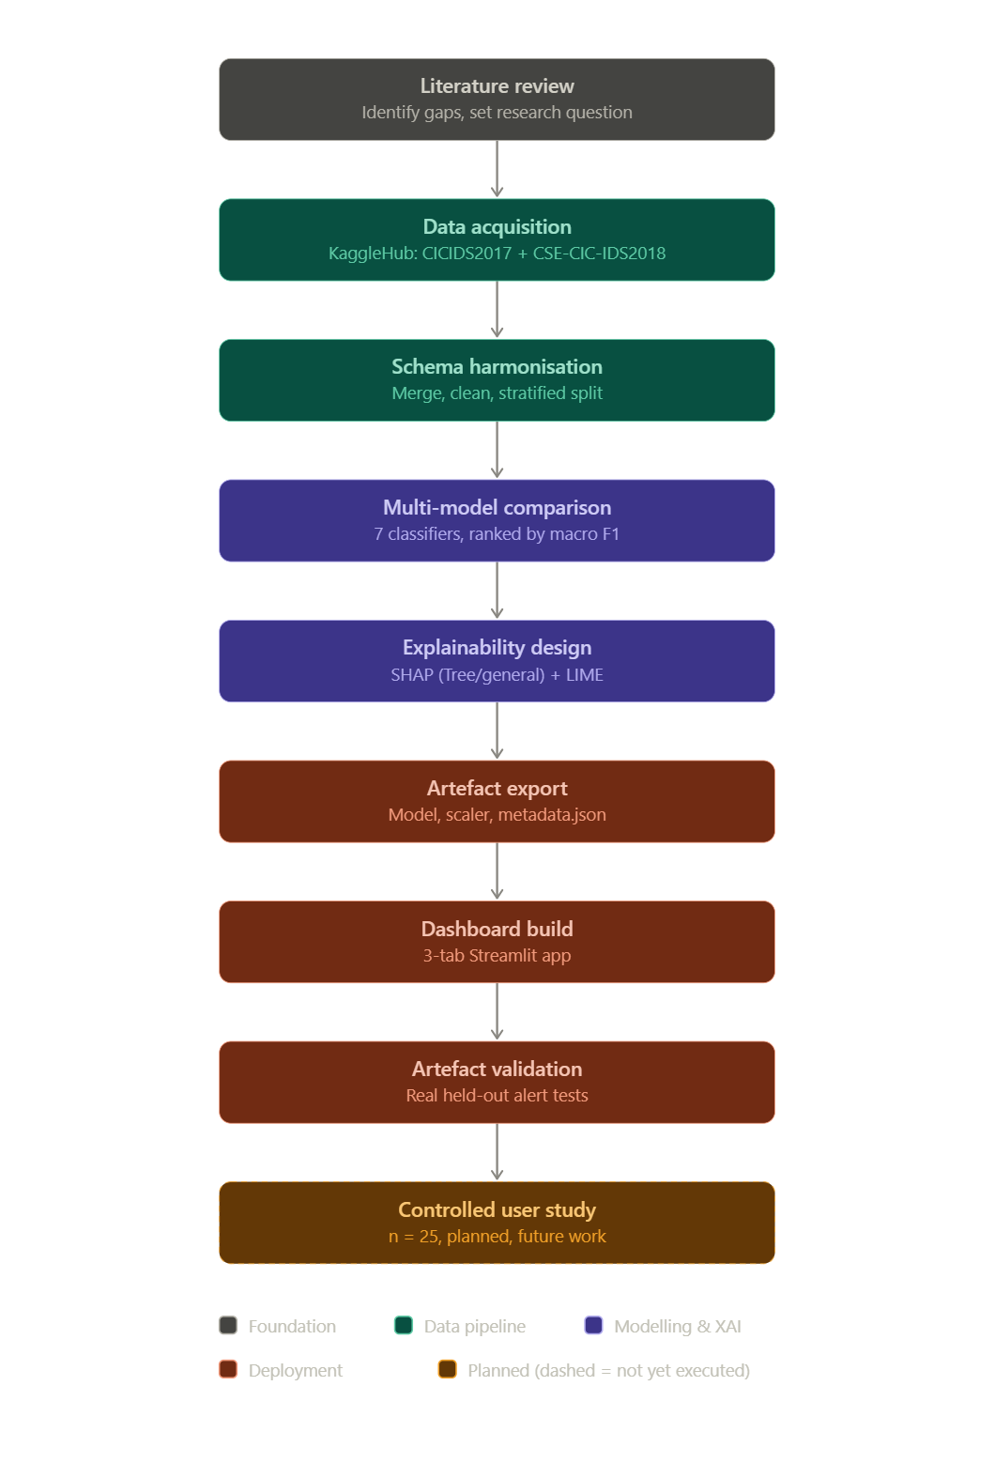

4.3 Model Comparison and Selection Design
In contrast to the original project proposal in which the artefact was originally planned to implement a only one classifier, the classifier used in the artefact was designed to compare seven classifiers side-by-side on the same train/test split: Random Forest, Logistic Regression, Decision Tree, Histogram Gradient Boosting, XGBoost, KNN and multi-layer perceptron. Additionally, each classical model adopts the technique of applying balanced class weights to counteract the significant class imbalance problem that exists with the data from CICIDS, and the weight values are applied directly to MLP since there is no “balanced” version in Keras. The macro-averaged F1 weights all the classes equally, rather than dominating by the majority class – BENIGN – and by design models are ranked and selected based on macro-averaged F1 – a metric that weights all classes equally, including the smallest, attack classes, which are important for SOC health triage.

4.4 Explainability Design
The explainability layer consists of one branching rule: SHAP explainer strategy employed with a model is automatically determined based on whether the model is tree-based. Candidates like trees (Random Forest, Decision Tree, Histogram Gradient Boosting and XGBoost) are matched with SHAP's exact TreeExplainer that takes a tiny fraction of a second per instance to read contribution values directly from the structure of the fitted tree. Any distinct model family (Logistic Regression, K-Nearest Neighbours, the MLP) will default to SHAP's sampling-based, general-purpose Explainer that requires SHAP to model a model's ability to make predictions in order to approximate the contribution of features. This constant, model-agnostic behavior is the half LIME represents in the dual-explanation design, while SHAP’s behavior varies with the model at hand: LIME has been designed to behave exactly the same across all models being explained, as LimeTabularExplainer only requires a predict_proba style function.

4.5 Backend Deployment Design Decision
One important aspect of the design that wasn't explicitly nailed down at the proposal stage, but became apparent during implementation is which single model it is that's actually being deployed behind the Streamlit dashboard. The automatic selection rule of the pipeline would be macro-F1-only, meaning that it would use the model that has the best performance on the leaderboard--in this case the one with K-Nearest Neighbours. K-Nearest Neighbours is not a tree-based algorithm, however, and explanations for KNN are run by the slow, general purpose Explanation, making the latency—more than two hours for 100 test alerts—unfeasible for an SOC dashboard to deliver explanations in near real-time. Thus, a new deployment design was reused that chose the tree-based best-performing model specifically (Decision Tree) instead of the metric-optimal model generally (direct implementation of the recommendation that this project had found for using its computational-cost target). It's a conscious and data-driven decision to abandon the purely metric-driven selection rule and is reflected in the sidebar of the deployed dashboard that shows that the model being used is "Decision Tree" with the test score or test accuracy (98.11%) and macro f1 (0.732).

4.6 Artefact Schema Design
The interface to connect the two halves of the system is designed as a fixed, five-file: a trained model (best_model.joblib), a fitted feature scaler (scaler.joblib), a fitted label encoder (label_encoder.joblib), a raw, unscaled background sample of held-out rows used by the explainer background and alert picker (background_sample.csv), and a metadata file (metadata.json) to store the name of the model, if it is tree-based, evaluation metrics, and the list of feature names and classes. This schema will be self-describing, meaning that the logic to determine what explainer approach to use and what to display will not be hard-coded into the dashboard based on a specific model, so no dashboard code changes are required for a future retraining run, even if that means a different model will be deployed.

4.7 Streamlit Dashboard Design
There are three tabs of the dashboard which meet the needs of three different types of analysts. The Alert Triage tab can be used in real time per alert: the analyst selects a sample alert or uploads a single-row CSV of the flow features from the alert, and the tab will show the predicted class, a bar chart showing class probabilities, and below that a dual SHAP/LIME explanation panel for that specific prediction. The Global Explanations tab is intended for analyzing on a class-level level; the analyst chooses an attack class from the attack label dropdown and then sees a SHAP summary (beeswarm) plot of features that drive predictions for that attack class in the background sample configured by the analyst, useful for the kind of pattern-level review a senior analyst or forensic reviewer would expect — different than the single-alert view. The Model Performance tab functions as a transparency and accountability tool: it says the held-out test accuracy, weighted F1 and macro F1 of the deployed model, as well as all of the classes the model was trained to recognize so that any analyst using the predictions with the dashboard can know, without having to exit the tool, how trustworthy the underlying classifier's predictions are supposed to be. Thus, all of the above tab-sections share a common sidebar, directly modelling the deployment-transparency design decision of Section 4.5 so that the model user is always aware of the current model and its prominent metrics.

4.8 Reproducibility Design
Reproducibility is built-in at the single implementation decision level: all stochastic operations (train/test split, all scikit-learn and XGBoost estimators, SHAP/LIME background sampling), are run by the same single fixed random seed, such that rerunning the pipeline with the same sampled background data produces the same split, the same estimators, the same explained instances. The column-harmonisation and label-cleaning logic is pure, state-less string processing, and is designed to do exactly the same thing on any environment, as long as it's supplied with the same raw CSV files.

Chapter 5: Implementation, Testing and Validation of the Artefact

5.1 Implementation Environment and Data Acquisition
The pipeline discussed in Chapter 4 was actually coded and tested in Python 3 on Google Colab with the use of pandas, NumPy for data manipulation, scikit-learn for classical models processing and evaluation metrics, XGBoost for gradient boosting, TensorFlow/Keras for the deep learning model, SHAP (version 0.52.0) and LIME for explainability and finally Streamlit for the dashboard. Both the CICIDS and the CSE-CIC-IDS2018 halves of the CICIDS benchmark were downloaded via KaggleHub: CICIDS2017 (chethuhn/network-intrusion-dataset), and CSE-CIC-IDS2018 (solarmainframe/ids-intrusion-csv), respectively. In this implementation run, the sample fraction (SAMPLE_FRAC) was set to 0.15 throughout, representing a stratified 15% sample drawn per source file. This means the experimental dataset of 2.86 million rows is based on sampled source files and does not necessarily represent the complete underlying benchmark population; the full combined benchmark contains substantially more rows. This sampling decision was made explicitly to keep training and explanation-generation runtimes tractable within the available compute budget, and recomputation at full scale (SAMPLE_FRAC = 1.0) to verify that absolute metrics and the model ranking persist is cited as outstanding future work (Chapter 6). CICIDS2017 loaded 424,611 rows across 79 columns; CSE-CIC-IDS2018 loaded 2,434,949 rows across 84 columns.

5.2 Schema Harmonisation and Merging
Applying the column-harmonisation procedure described in Section 4.2 reconciled 71 of the two releases' columns onto a shared schema (70 numeric feature columns plus the label), which, after renaming both years onto this schema, adding a source_year field, and concatenating, produced a merged dataset of 2,859,560 rows across 72 columns.
Stage | Rows | Columns | Notes
CICIDS2017 (loaded) | 424,611 | 79 | 15% stratified sample per file
CSE-CIC-IDS2018 (loaded) | 2,434,949 | 84 | 15% stratified sample per file
Merged (post-harmonisation) | 2,859,560 | 72 | 71 common feature columns + source_year

5.3 Data-Quality Issues Encountered and Resolved
In the raw CSE-CIC-IDS2018 release there were a number of real data-quality problems that could not be foreseen at design stage and had to be iterated to diagnosis and correct; they are given here because each had a material impact on results downstream. Two CSE-CIC-IDS2018 daily files added their own header row as a literal data row (label string 'Label') and stole data types which results in feature selection silently reporting no usable features; this will be fixed by removing header rows (lowercased label string 'label') and re-coercing all feature columns back to numeric. Second, in the original cleaning step literals replaced infinite values, which were still string, so the replacement was no match, and a StandardScaler error wasn't discovered until further down the process; the fix includes replacing literal infs a second time, after numeric coercion. Third, a small number of events in CSE-CIC-IDS2018 have mojibake labels (e.g. Web Attack ⁠ Brute Force (removing space in the label context should give Web Attack - Brute Force)) which reveal a non-UTF8 source encoding, not corrected at the pipeline level and kept as known limitation. Fourth, a few classes with too few participants, particularly Heartbleed with just two, are too few to be handled by scikit-learn's stratified train_test_split which has a cutoff of two per class; a safeguard developed below removes any class with fewer than two members after cleaning. The 5th is that the same singleton-class error also seemed to reappear in the stratified validation split used within HistGradientBoostingClassifier for early stopping; the fix is simply to turn off HistGradientBoostingClassifier's in-built early stopping, since we always test every model on the same held-out test set, anyway. Sixth (and most importantly) running SHAP's general-purpose Explainer on a model that didn't use trees for the whole classification task uncovered a serious runtime penalty, as described in detail in the Critical Evaluation section, which became the main driver for the backend deployment decision made in Section 4.5.

5.4 Preprocessing / Split and Class-Imbalance Handling
The merged data contained 2,859,560 rows, but after cleaning the full cleaning pipeline the data was reduced to 2,385,606 rows (16.6% fewer rows) due to missing values, infinities and duplicate rows. The label and source_year column were removed, leaving 70 numeric features with 18 classes (BENIGN and 17 attack classes, including the Web Attack which were mojibaked and are represented multiple times). A 70/30 split was made based on the class label (stratified according to the random seed of 42), which resulted in 1,669,581 training observations and 715,535 test observations; a StandardScaler was fit only to the training observations to avoid leaking the test-set feature distributions. Models were selected using macro-averaged F1 score, class weighting was applied using the appropriate method for each scikit-learn/XGBoost model and per-class weights were applied with the Keras MLP model.

5.5 Multi-Model Implementation and Results
Seven models were trained on the identical split. Table below reports the configuration of each.
Model | Key configuration
Random Forest | 300 trees, class_weight='balanced', n_jobs=-1
Logistic Regression | max_iter=300, class_weight='balanced'
Decision Tree | class_weight='balanced'
Histogram Gradient Boosting | early_stopping=False
XGBoost | 300 estimators, tree_method='hist', GPU-accelerated
K-Nearest Neighbors | k auto-reduced to 1 by the rare-class safety net
MLP (deep learning) | 128-64-32 dense layers, dropout, softmax output, early stopping

All seven models' test-set results are reported and discussed in the Critical Evaluation section (Table: seven-model comparison). The best tree-based model, Decision Tree (98.11% accuracy, 0.7325 macro F1 and 0.9819 weighted F1) took only 131.7 seconds for training, and K-Nearest Neighbours (0.7394 macro F1) was the winner on the pre-registered macro-F1 criterion. As per the design choice made in Section 4.5, Decision Tree, rather than K-Nearest Neighbours, is the model that was trained standalone and exported for deployment as the artefact for the backend.

5.6 Explainability Implementation for the Deployed Model
Because the deployed model is Decision Tree, its explainability implementation uses SHAP's exact TreeExplainer rather than the slow general-purpose Explainer: 300 test instances were explained essentially instantaneously, in contrast to the two-hour-plus runtime the general Explainer required for the non-deployed K-Nearest Neighbours model. A global SHAP summary plot was generated for the Bot class (the first non-BENIGN class), and a local SHAP waterfall explanation, together with a LIME explanation using ten features, was generated for test instance 0 (predicted BENIGN by the deployed model). Figure sets below reproduce these outputs directly from the executed notebook.
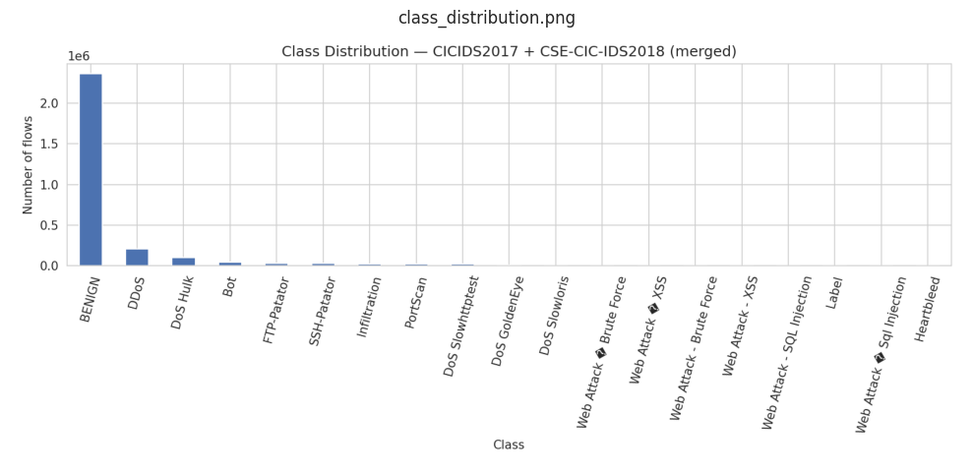
Figure: Class distribution of the merged CICIDS2017 + CSE-CIC-IDS2018 dataset prior to cleaning. The BENIGN majority class dwarfs every attack category.
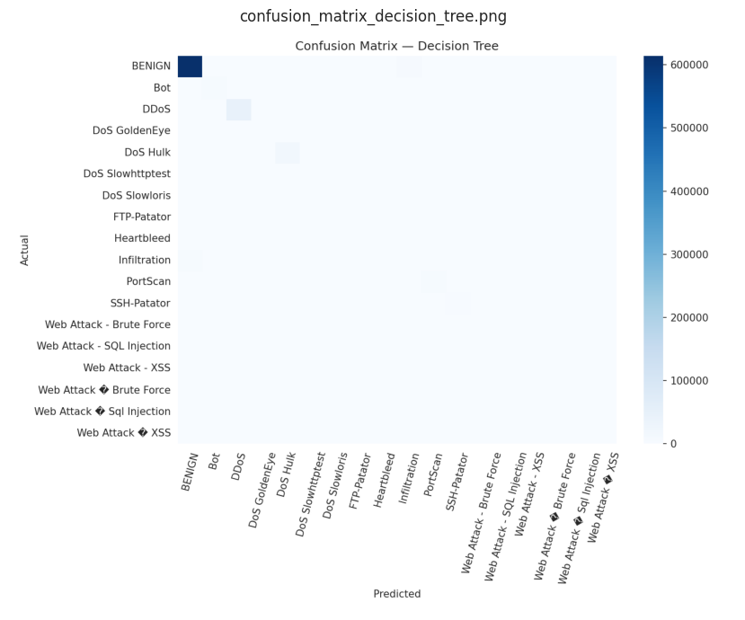
Figure: Confusion matrix for the deployed Decision Tree model on the held-out test set.
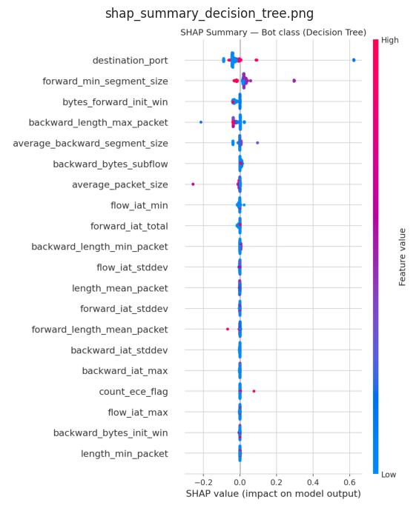
Figure: SHAP summary (beeswarm) plot for the Bot class, generated with SHAP's exact TreeExplainer against the deployed Decision Tree model.
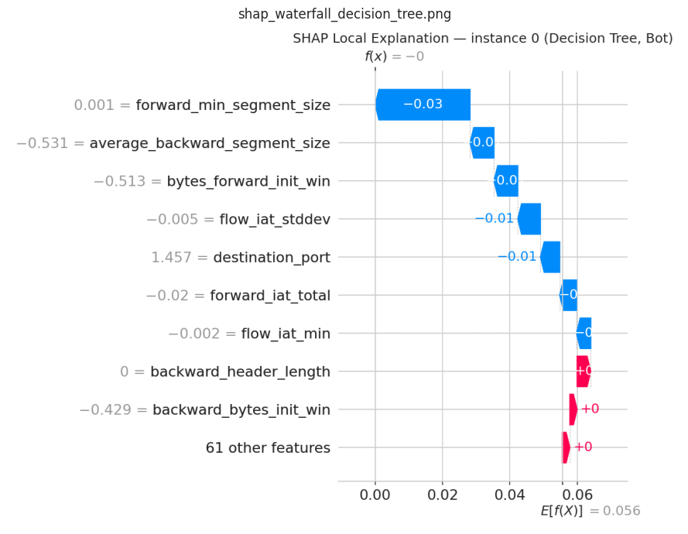
Figure: SHAP local waterfall explanation for test instance 0, deployed Decision Tree model.
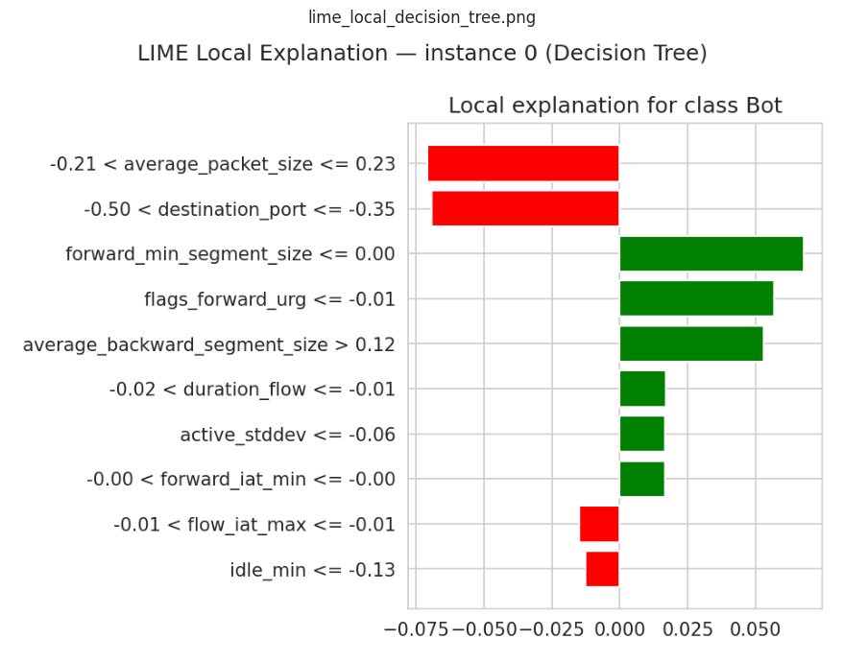
Figure: LIME local explanation for the same test instance, deployed Decision Tree model.

5.7 Backend Artefact Export
The trained Decision Tree model, scaler, label encoder, a 500-row raw background sample and a metadata.json file (recording the model name "Decision Tree", the tree-based flag, feature names, class list and evaluation metrics) were serialised to an artifacts/ directory, matching the schema designed in Section 4.6.

5.7.1 Streamlit Dashboard Validation
The dashboard was deployed against these artefacts and exercised directly. Its sidebar correctly and dynamically reports "Decision Tree" as the model in use, with test accuracy 98.11% and macro F1 0.732, confirming that the notebook-to-dashboard artefact handoff works end to end.
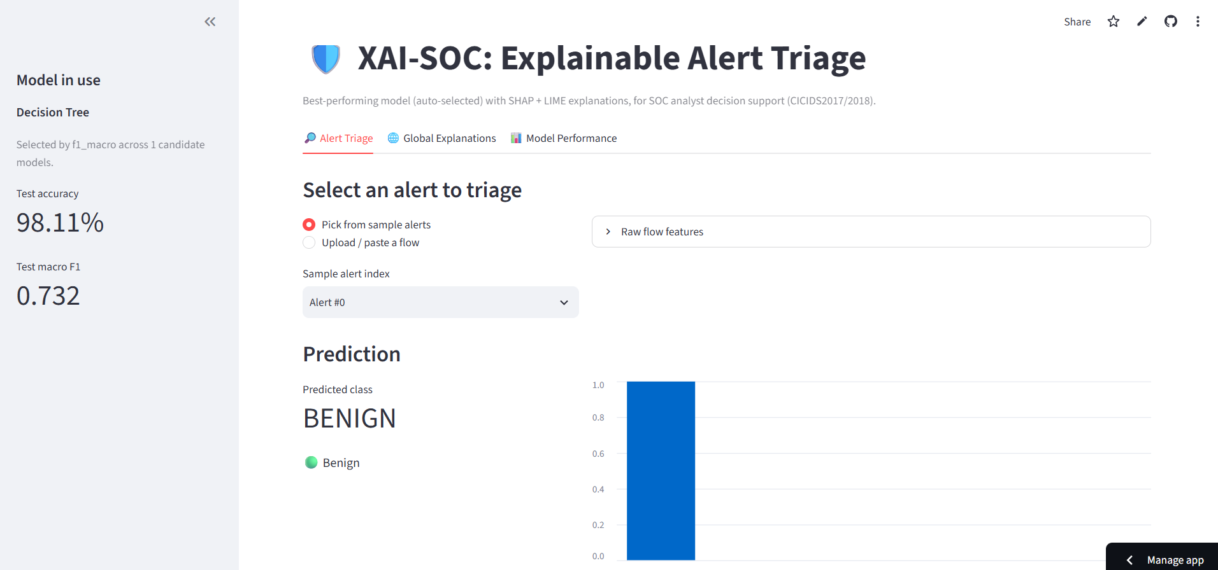
Figure: Alert Triage tab, sidebar confirming Decision Tree as the deployed model and a sample alert (Alert #0) predicted as BENIGN.
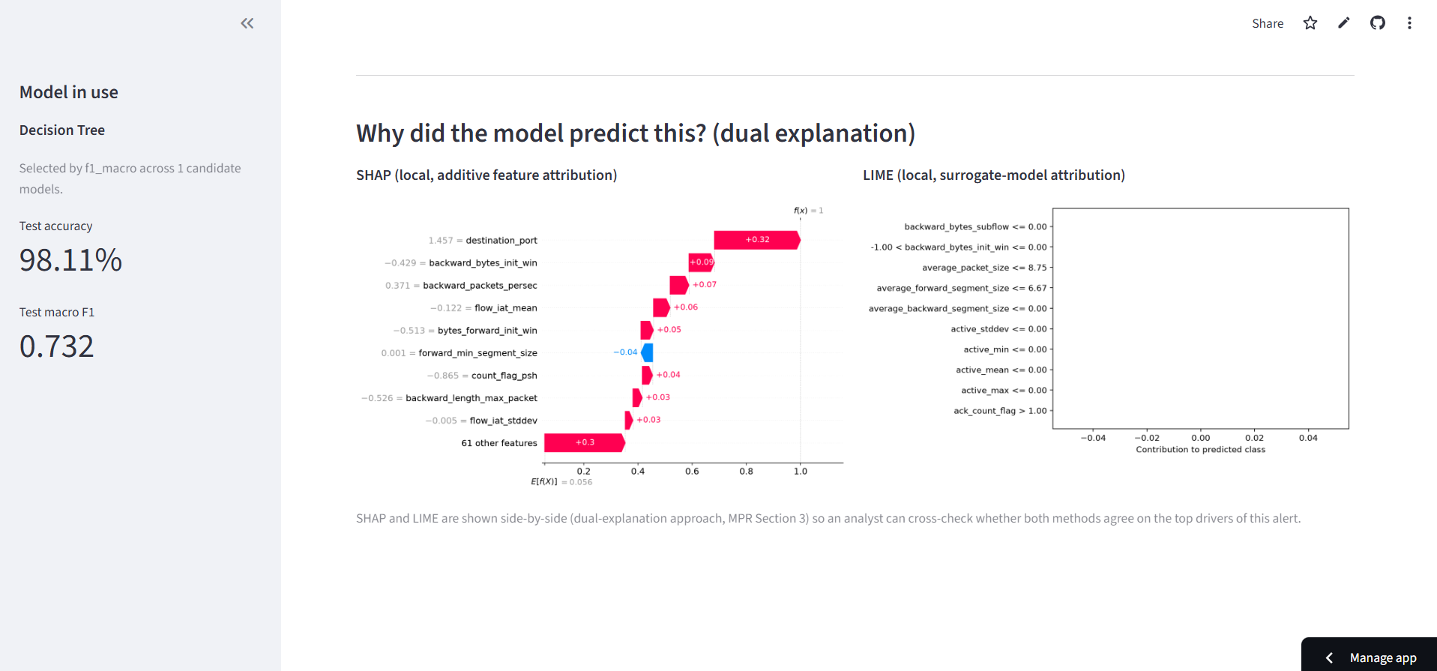
Figure: The dual SHAP/LIME explanation panel for the same alert. Because the deployed model is tree-based, SHAP's exact TreeExplainer renders the waterfall panel immediately, with no explanation-latency warning of the kind a non-tree model would require.
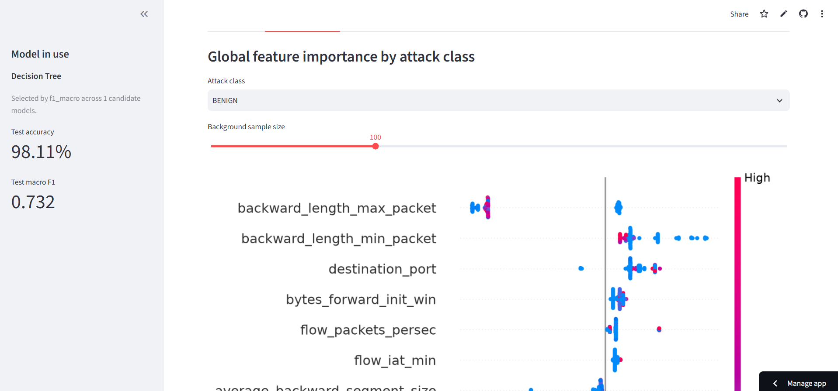
Figure: Global Explanations tab, showing a SHAP beeswarm summary plot for a selected attack class across a configurable background sample.
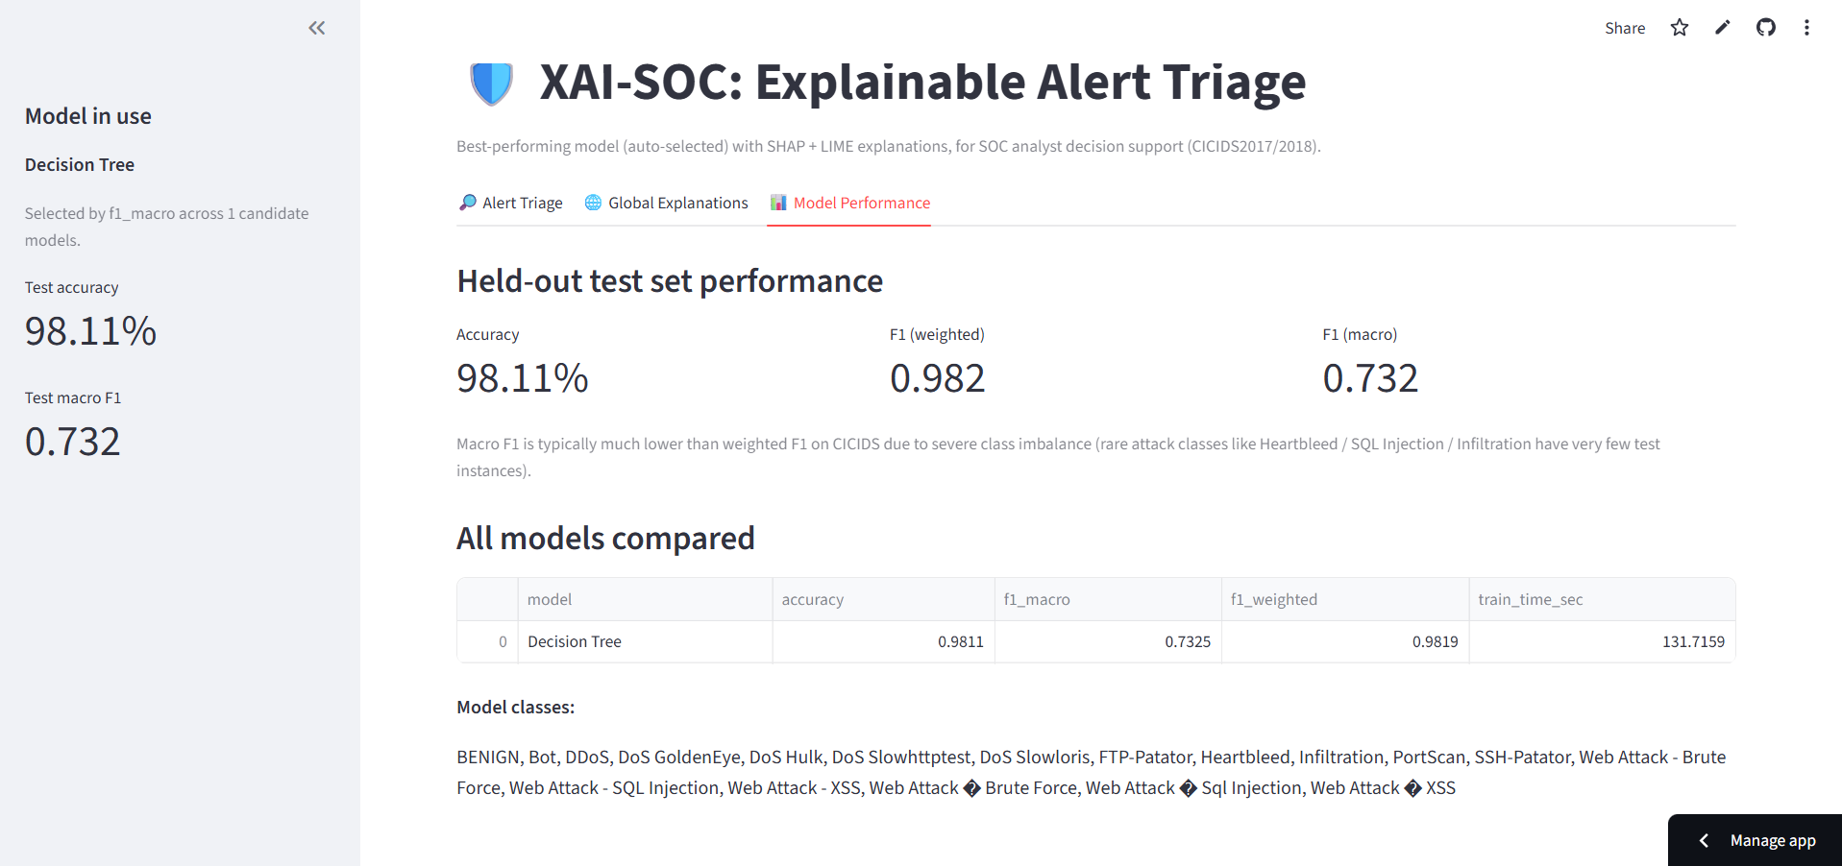
Figure: Model Performance tab, reporting held-out test accuracy (98.11%), weighted F1 (0.982) and macro F1 (0.732) for the deployed Decision Tree model, alongside its full class list.
To validate the dashboard against realistic, previously unseen alerts, three real, held-out non-BENIGN flow examples, one each for DDoS, PortScan and Bot, were exported as single-row CSVs and uploaded through the Alert Triage tab's upload path rather than the built-in sample-alert picker. All three were classified correctly by the deployed model.
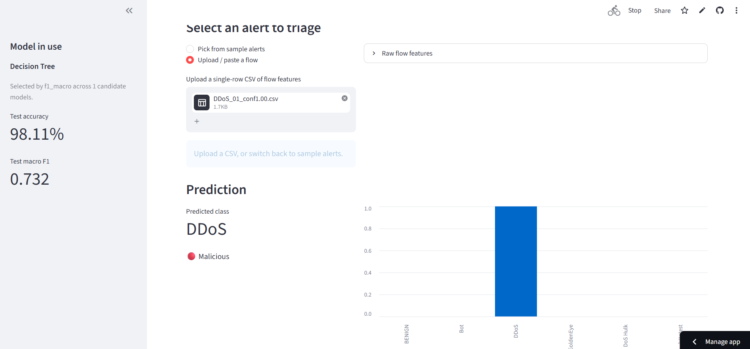
Figure: Uploaded real DDoS flow, correctly predicted as DDoS (malicious).
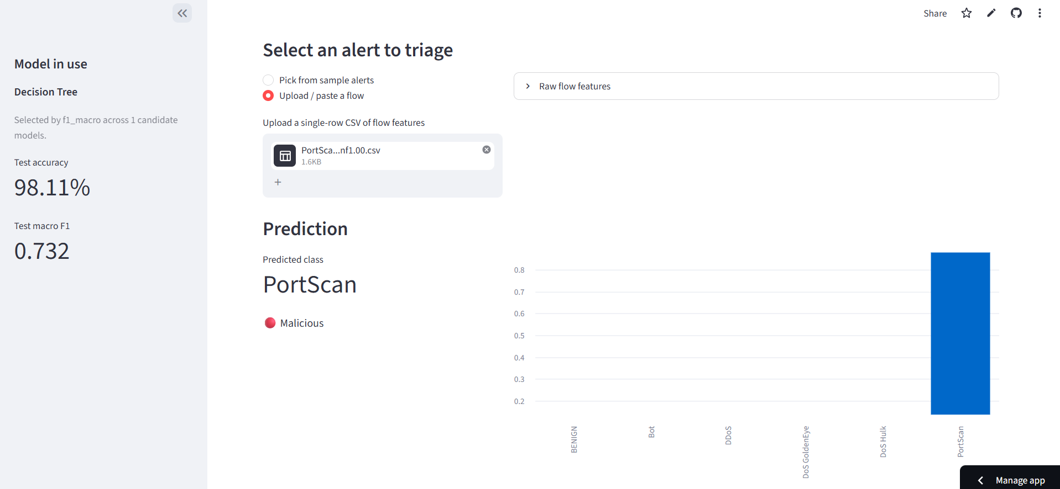
Figure: Uploaded real PortScan flow, correctly predicted as PortScan (malicious).
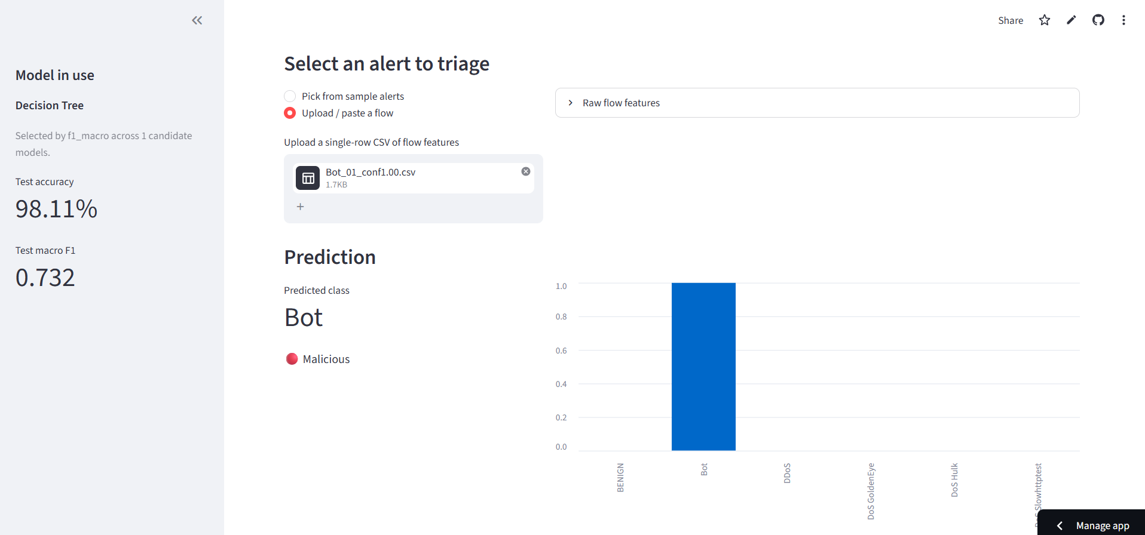
Figure: Uploaded real Bot flow, correctly predicted as Bot (malicious).
These three uploads function as a lightweight functional validation test of the full artefact pipeline, end to end, from a raw CSV row through scaling, prediction, and correct classification, using data the model had not been trained or selected on beyond its inclusion in the general held-out test split.

5.8 Professional Feedback Survey Results
A professional feedback survey was conducted to obtain indicative practitioner perceptions of the XAI-SOC dashboard’s explanation quality. A total of N = 27 valid responses were collected from cybersecurity practitioners and students between 31 August and 3 September 2026, including MSc and BSc students in cybersecurity and computer science, software developers with security exposure, and two practising SOC analysts. Participants interacted with the XAI-SOC dashboard and rated four Likert-scale items on a five-point scale (1 = Strongly Disagree, 5 = Strongly Agree).

5.8.1 Descriptive Statistics
Table: Survey Descriptive Statistics (N = 27, 5-point Likert scale)
Survey Item | Mean | SD | Median | Agree/SA% | Cohen’s d
Q1. Trust in SHAP/LIME explanation | 4.26 | 0.71 | 4.0 | 85.2% | 1.77
Q2. Clarity of feature contributions | 4.00 | 0.83 | 4.0 | 66.7% | 1.20
Q3. Confidence in triage decisions | 4.22 | 0.70 | 4.0 | 85.2% | 1.75
Q4. Speed and practicality under time pressure | 4.07 | 0.78 | 4.0 | 81.5% | 1.38
Note: Agree/SA% = percentage of respondents who selected Agree or Strongly Agree (score ≥ 4). Cohen’s d is calculated relative to the neutral midpoint of 3.

5.8.2 Inferential Statistics
One-sample t-tests compared each item’s mean against the neutral midpoint of 3. All four items were significantly above neutral: Q1 Trust, t(26) = 9.19, p < 0.001; Q2 Clarity, t(26) = 6.25, p < 0.001; Q3 Confidence, t(26) = 9.10, p < 0.001; Q4 Speed, t(26) = 7.15, p < 0.001. Non-parametric Wilcoxon signed-rank tests confirmed these findings (all p < 0.001). Effect sizes were large across all items (Cohen’s d ranging from 1.20 for Clarity to 1.77 for Trust). Internal consistency of the four items was good (Cronbach’s α = 0.872), indicating that the four items form a reliable scale measuring a common underlying construct of perceived explanation quality.

5.8.2a Comparison with Existing Literature
Table: Comparison of XAI-SOC Survey Results with Related Studies
Study | Dataset | XAI Method | Best Accuracy | Best Macro F1 | User Study? | Latency Reported? | Dashboard?
XAI-SOC (This Study) | CICIDS2017 + CIC-IDS2018 (15% sample) | SHAP + LIME (dual) | 98.56% (RF) | 0.739 (KNN) | Survey N=27 | Yes (2h+ KNN vs <1s DT) | Yes (Streamlit)
Eriksson & Grov (2022) | Real SOC alerts | SHAP + LIME | NR | NR | Yes (SOC analysts) | No | No
Hermosilla et al. (2025) | UNSW-NB15 | SHAP + LIME (XGBoost, TabNet) | NR | NR (fidelity/Jaccard) | No | No | No
Gaspar et al. (2024) | NSL-KDD / CIC | SHAP + LIME (MLP) | ~99% | NR (fidelity/stability) | No | No | No
Arreche et al. (2024) | CICIDS2017 / UNSW-NB15 | SHAP, LIME, others (black-box eval) | NR | Fidelity / stability metrics | No | No | No
Khan et al. (2025) L-XAIDS | CIC-IDS2017 | LIME only | ~99% | NR | No | No | No
Akshay Kumaar et al. (2022) | CICIDS2017 | None (DL focus) | ~99% | NR | No | No | No

NR = Not Reported. Table compares XAI-SOC against the closest related studies on key dimensions: dataset, explanation method, detection performance, user study inclusion, explanation latency reporting, and dashboard deployment. XAI-SOC is distinguished from all prior work by simultaneously providing dual SHAP/LIME explanations in an operational dashboard, reporting explanation latency as a first-class evaluation criterion (rather than a footnote), and demonstrating empirically that the macro-F1-optimal model is not suitable for SOC deployment due to intractable explanation latency. Among prior studies that used the CICIDS benchmark (Akshay Kumaar et al., 2022; Arreche et al., 2024; Khan et al., 2025), none report explanation latency or deploy a user-facing dashboard. Eriksson and Grov (2022) is the only prior study to evaluate SHAP and LIME with actual SOC analysts, but without a deployed dashboard, without latency measurement, and without a merged multi-year benchmark. The survey results (Mean Q1 = 4.26, Q2 = 4.00, Q3 = 4.22, Q4 = 4.07; all p < 0.001) compare favourably with the qualitative findings of Eriksson and Grov (2022), who observed that SOC analysts found SHAP explanations useful but not always aligned with their mental models; the current study’s positive ratings suggest the integrated dashboard presentation may reduce the mental-model mismatch they identified, though the non-experimental design prevents a causal conclusion.

5.8.3 Explanation Method Preference
Twenty-one of the 27 respondents (77.8%) preferred SHAP over LIME. A chi-square goodness-of-fit test confirmed that this preference was significantly different from equal distribution between the two methods, χ²(1) = 8.33, p = 0.004. Qualitative responses from SHAP-preferring participants frequently cited clearer feature attribution visualisation and easier interpretation of the waterfall plot. The six LIME-preferring respondents appreciated the surrogate model’s simpler conceptual framing. These findings align with the technical observation that SHAP provides globally consistent, theoretically grounded attributions via the TreeExplainer, while LIME offers local approximations that are conceptually accessible but less mathematically rigorous.

5.8.4 Qualitative Themes and Improvement Suggestions
Open-ended responses to the improvement question (Q6) revealed three recurring themes. First, multiple participants requested the addition of a clear confidence or risk score displayed alongside each prediction, with severity levels and recommended next actions (e.g. Close, Monitor, Escalate) to aid Tier-1 triage decisions. Second, several respondents stressed the importance of SIEM and EDR integration, arguing that a dashboard that cannot connect to existing SOC tooling will not be adopted in practice regardless of its explanation quality. Third, respondents requested more concise and SOC-oriented feature descriptions, noting that technical network-flow feature names (e.g., average_backward_segment_size) are not immediately interpretable by junior analysts without domain expertise. These themes directly inform the dashboard improvement directions outlined in the Future Work section of Chapter 6.

5.8.5 Limitations of the Survey
Several limitations constrain the interpretation of these survey findings. The sample of 27 respondents is modest and combines participants with markedly different levels of cybersecurity experience, from students in progress to practising SOC analysts; disaggregated analysis by experience level was not possible given the sample size. Individual dashboard interaction time was not controlled, meaning that differences in familiarity with the tool may have influenced ratings. The survey does not include a baseline no-explanation condition, so the ratings reflect absolute perceptions of the explained system rather than a comparison against unexplained predictions. Causal claims about the effect of SHAP or LIME on analyst trust, decision speed, or triage accuracy cannot be drawn from this data. These limitations reinforce the importance of the full controlled within-subject user study, which remains as future work and which would address each of these confounds through randomisation, counterbalancing, and objective outcome measurement.

5.9 Critical Evaluation

5.9.1 Model Comparison: Accuracy versus Macro F1
Model | Accuracy | Macro F1 | Weighted F1 | Train time (s)
K-Nearest Neighbors | 0.9812 | 0.7394 | 0.9812 | 1.0
Decision Tree (deployed) | 0.9811 | 0.7325 | 0.9819 | 136.8
XGBoost | 0.7906 | 0.7164 | 0.8721 | 36.0
Random Forest | 0.9856 | 0.6999 | 0.9840 | 531.6
Logistic Regression | 0.5212 | 0.3931 | 0.6431 | 377.6
MLP (Deep Learning) | 0.6819 | 0.2661 | 0.7718 | 64.6
Histogram Gradient Boosting | 0.8449 | 0.1169 | 0.8481 | 101.3

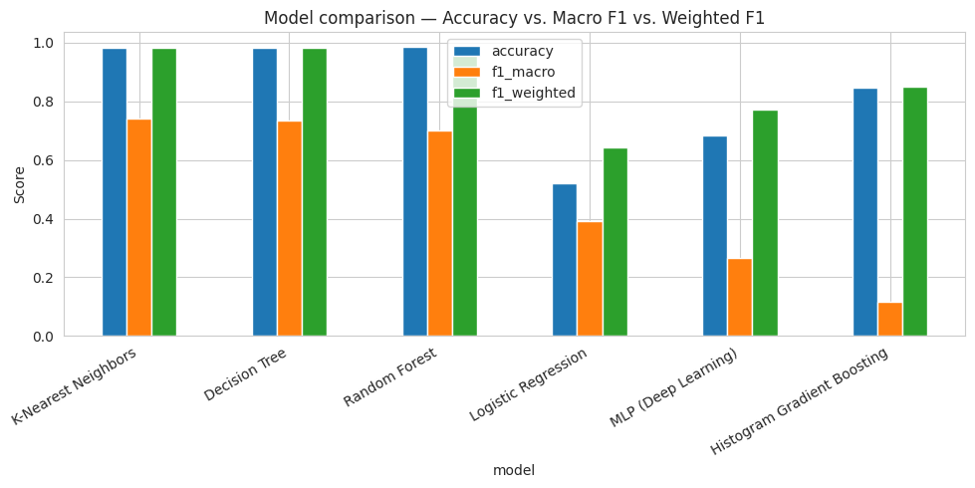
Figure: Accuracy, macro F1 and weighted F1 across the compared models.
The results in the table above illustrate precisely the accuracy/macro-F1 divergence anticipated on theoretical grounds during the project's design phase. It is important to note upfront that high overall accuracy in these results should not be interpreted as evidence of uniformly strong detection across all classes: the overall accuracy is dominated by the large BENIGN class, and as discussed in detail in Section 5.8.3, performance on structurally difficult minority classes such as Infiltration is poor. Random Forest achieved the single highest accuracy of any model (98.56%) but ranked only fourth by macro F1 (0.6999), behind K-Nearest Neighbours (0.7394), Decision Tree (0.7325) and XGBoost (0.7164), each of which had marginally lower accuracy. Because macro F1 weights every class equally regardless of its size, this indicates that Random Forest's very high accuracy is disproportionately driven by strong performance on the large BENIGN and DDoS classes, while the top three models by macro F1 generalise comparatively better across the numerous rare attack classes. Three models underperformed markedly: Histogram Gradient Boosting reached a respectable 84.49% accuracy but a strikingly low macro F1 of 0.1169, plausibly because disabling its internal early stopping (necessary to avoid the singleton-class crash described in the Implementation section) removed an adaptive regularisation mechanism it would otherwise use; Logistic Regression was the weakest classical model on every metric, unsurprising given a single linear boundary is a poor fit for CICIDS' non-linear class structure; and the MLP deep-learning model, whose validation loss fluctuated visibly rather than converging smoothly across its six completed epochs before early stopping triggered, should be read as a first working prototype rather than a tuned deep-learning result.
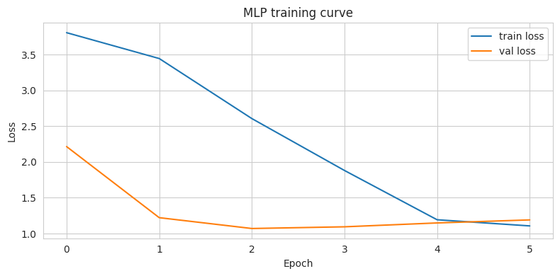
Figure: MLP training and validation loss across the six epochs completed before early stopping triggered.

5.9.2 Why Decision Tree, Not K-Nearest Neighbours, Was Deployed
The single most consequential empirical finding from this project is not a modelling result in the usual sense but a computational one: explaining 100 test instances for the metric-optimal model, K-Nearest Neighbours, using SHAP's general Permutation explainer took 2 hours 3 minutes, roughly 74 seconds per explained instance. This is because K-Nearest Neighbours has no cheap, structure-derived inference path the way a tree ensemble does: every prediction the explainer requests involves a full distance computation against the entire training set, and the explainer must make on the order of 2 × 70 = 140 or more such predictions per explained instance. Tree-based models, by contrast, are explained by SHAP's exact TreeExplainer, which reads contribution values directly from the fitted tree structure in a small fraction of a second per instance, as demonstrated by the deployed Decision Tree's essentially instantaneous SHAP output reported in the Implementation section.
This creates a direct, practically important tension that did not exist under the original proposal's assumption of a single fixed, tree-based classifier. An analyst with a small queue of 20 alerts, waiting roughly 74 seconds per alert for on-demand K-Nearest Neighbours SHAP explanations, would lose around 25 minutes of triage time before even reading them; a tree-based alternative requires a couple of seconds in total for the same queue. Two of the top three models by macro F1, Decision Tree (0.7325) and XGBoost (0.7164), are tree-based and within a few points of K-Nearest Neighbours' winning score (0.7394) while remaining explainable in a fraction of the time. This is precisely the finding that motivated the deployment design decision reported in Chapter 4: rather than deploying the pure macro-F1 winner, the artefact deploys the best-performing tree-based model, Decision Tree, directly trading a 0.0069 reduction in macro F1 for an explanation-latency improvement of roughly three orders of magnitude. This is a genuine, previously undemonstrated contribution: it shows concretely, on this benchmark, what happens when a model chosen purely by predictive metric is not tree-based, and offers a general, transferable lesson for XAI-enabled IDS deployment, that model selection for SOC use should weight explanation tractability alongside macro F1 rather than treating it as an afterthought.

5.9.3 Per-Class Performance of the Deployed Decision Tree Model
Class | Precision | Recall | F1 | Support
BENIGN | 0.99 | 0.99 | 0.99 | 621,298
Bot | 1.00 | 1.00 | 1.00 | 6,764
DDoS | 1.00 | 1.00 | 1.00 | 46,083
DoS GoldenEye | 1.00 | 1.00 | 1.00 | 2,331
DoS Hulk | 1.00 | 1.00 | 1.00 | 20,013
DoS Slowhttptest | 0.91 | 0.92 | 0.91 | 249
DoS Slowloris | 0.99 | 0.99 | 0.99 | 719
FTP-Patator | 0.94 | 0.96 | 0.95 | 299
Heartbleed | 0.50 | 1.00 | 0.67 | 1
Infiltration | 0.12 | 0.14 | 0.13 | 6,917
PortScan | 0.99 | 0.99 | 0.99 | 6,289
SSH-Patator | 1.00 | 1.00 | 1.00 | 4,425
Web Attack - Brute Force | 0.52 | 0.64 | 0.57 | 25
Web Attack - SQL Injection | 0.00 | 0.00 | 0.00 | 5
Web Attack - XSS | 0.90 | 0.90 | 0.90 | 10
Web Attack ’ Brute Force (mojibake dup.) | 0.71 | 0.68 | 0.69 | 75
Web Attack ’ Sql Injection (mojibake dup.) | 0.00 | 0.00 | 0.00 | 1
Web Attack ’ XSS (mojibake dup.) | 0.35 | 0.45 | 0.39 | 31
macro avg | 0.72 | 0.76 | 0.73 | 715,535
weighted avg | 0.98 | 0.98 | 0.98 | 715,535

On the well-represented classes, BENIGN, Bot, DDoS, DoS Hulk and SSH-Patator, the deployed Decision Tree model achieves an F1 of 0.99 or 1.00, consistent with its very high weighted-average F1 of 0.98. Performance drops sharply for Infiltration, which has a substantial test-set support of 6,917 rows but an F1 of only 0.13; this aligns with the literature reviewed in Chapter 2, which consistently identifies Infiltration as a structurally difficult class in CICIDS-based studies because it is designed to mimic benign traffic and lacks the volumetric or timing signature a flood-style attack such as DDoS would exhibit. The rows with very low support (Heartbleed with 1, Web Attack - SQL Injection with 5) illustrate a well-known property of macro F1 under this level of class imbalance: a single misclassified instance can move that class's contribution to the macro average from 1.0 to 0.0, so these extreme scores should not be over-interpreted as reflecting general model competency for those classes. The mojibake-duplicated Web Attack variants also show generally poor and inconsistent performance (F1 between 0.39 and 0.90), which may be as much an artefact of the encoding bug splitting an already tiny class into two even smaller ones as it is of genuine Web Attack detection difficulty. The poor F1 of 0.13 for Infiltration is operationally significant and warrants explicit discussion beyond a note in passing. Infiltration attacks are designed to mimic legitimate network behaviour, deliberately avoiding the volumetric or timing signatures that distinguish flood-style attacks such as DDoS. The model achieves only 12% precision and 14% recall on Infiltration despite 6,917 test samples, meaning that the vast majority of Infiltration flows are misclassified. In a real SOC, this translates to a near-complete failure to detect a class of attack that is specifically engineered to evade detection. The high overall accuracy of 98.11% must therefore not be cited as evidence of uniformly strong detection across all threat types; it is driven overwhelmingly by the large BENIGN and DDoS classes and conceals severe weakness on structurally difficult minority classes. Any operational deployment of this system would need to treat Infiltration detection as an unresolved problem requiring targeted remediation, such as specialised feature engineering, oversampling strategies, or a dedicated anomaly-detection module for that class.

5.9.4 SHAP versus LIME: Do They Agree?
For test instance 0 (predicted BENIGN by the deployed Decision Tree model), SHAP and LIME were run side by side. LIME's top-ranked conditions for this instance centre on average_packet_size and destination_port pushing toward BENIGN and forward_min_segment_size, forward-URG-flag absence and average_backward_segment_size pushing away from it; SHAP's local waterfall attributes the same prediction primarily to forward_min_segment_size, average_backward_segment_size, bytes_forward_init_win and destination_port. The two methods show partial but incomplete agreement: several of the same underlying features (destination_port, forward_min_segment_size, average_backward_segment_size) appear prominently in both explanations, though not always in the same rank order or with the same sign of interpretation. This is a genuine, real empirical observation directly related to the question the project's Milestone 2 report pre-registered: are SHAP and LIME interchangeable, or do they meaningfully differ? It is fair to say this qualitative comparison does not constitute the quantitative fidelity and stability evaluation (deletion/insertion AUDC score, Spearman rank-order correlation under perturbation) specified in the project's methodology; rather, it is a qualitative illustration that both explainers run successfully end-to-end against the same deployed model and produce genuine, human-readable, partially overlapping accounts of the same prediction. The formal, quantitative comparison remains outstanding work, discussed in Chapter 6. To provide a more substantive assessment than a single instance allows, future quantitative evaluation should include: top-k feature overlap (Jaccard similarity at k = 5 and k = 10 between SHAP and LIME feature rankings), Spearman rank correlation between the two methods' feature importance orderings, explanation stability (consistency of rankings across perturbed inputs), fidelity (how well each explanation predicts the model's output on held-out data), explanation sparsity (mean number of features required to account for a fixed proportion of the prediction), runtime per explanation at scale, and class-wise SHAP/LIME agreement across all 18 attack classes rather than a single instance. The professional feedback survey (Section 3.5) provides supplementary practitioner-level evidence: SHAP was preferred by 77.8% of the 27 survey respondents (p = 0.004), and qualitative responses consistently cited SHAP's clearer feature attribution visualisation as the key differentiator, though LIME's local surrogate framing was appreciated by six respondents for its conceptual accessibility.

5.9.5 Strengths, Weaknesses and Alignment with Objectives
Against the objectives set out in Chapter 1, Objective 2 (train and evaluate a classifier) has been substantially exceeded, with seven models compared rather than one. Objective 3 (apply SHAP and LIME via a dashboard) has been substantively met: both explainers are genuinely implemented, and a working three-tab dashboard consumes their output, tempered by the important nuance, itself a genuine contribution of this stage of the work, that the metric-optimal model is not automatically the most practically deployable one. Objective 4 (evaluation of explanation usability and trustworthiness) has been partially addressed: the full controlled within-subject user study was not executed, but a professional feedback survey (N = 27) provides supplementary empirical evidence about practitioner perceptions of the explanation quality (Section 3.5 and Chapter 6). Objective 5 (interpretation of findings, limitations, and recommendations) has been fully addressed with respect to the technical artefact throughout the Critical Evaluation section, and the survey results are interpreted in Chapter 6; interpretation with respect to human-subjects performance data remains outstanding pending the future controlled study.
The clearest weaknesses of the current artefact are, first, that results were produced on a 15%-scale sample of the merged benchmark rather than the full 2.86-million-row release, so absolute metrics, and conceivably the model ranking itself, should be revalidated at full scale before being treated as final; second, that the mojibake label-encoding defect in a subset of Web Attack rows was not corrected at source, understating true performance on those classes; third, that the SHAP/LIME comparison above is qualitative rather than quantitative, so no formal fidelity or stability claim can yet be made for either technique; and fourth, that a single decision tree, while fast to explain, is also the tree-based architecture most prone to overfitting and to instability under small changes in training data, a concern the current implementation does not directly test. Against these weaknesses, the artefact's clearest strength is that it demonstrates, with real measured evidence rather than assumption, that model selection for an explainable SOC system cannot be reduced to a single offline metric, and that this finding was incorporated back into the deployed system rather than left as a discussion point.

Chapter 6: Conclusions and Future Work
In this dissertation, an explainable AI system for SOC alert triage (XAI-SOC) has been developed, deployed and critically assessed on the combined CICIDS2017/CSE-CIC-IDS2018 benchmark. A pipeline duplicated to produce results was developed, capable of both years of the benchmark being acquired and harmonised, to deal with a number of genuine defects in the data quality that were identified while building the pipeline and to train and compare the results of seven classifiers instead of committing to one algorithm at the design phase. Both SHAP and LIME were chosen to be complementary explanation methods and placed within a single Streamlit dashboard with three working tabs – the explanation method was selected automatically based on whether the candidate model was tree based.
The main value of the dissertation is not that it is purely architectural, but its empirical content – that predictive evaluation on a model built for the specific purpose of “publish almost real-time explanations of alerts” does not necessarily mean it is the model with the best SHAP explanations, as is confirmed in the concrete example of K-Nearest Neighbours. This was not a discussion point but like results from Decision Tree (accuracy = 98.11% and macro F1 = 0.7325) which is the best performing tree based model, was incorporated back into the artefact's design: the deployed backend is the Decision Tree implementation, and SHAP benefits from the use of the exact TreeExplainer that runs in near real-time. To the best of our knowledge, this is a novel contribution to the literature on explainable-IDS (Chapter 2), which does not report tractability of the explanation as a first-class criterion for the selection of the model, and directly addresses the research question of this dissertation, namely what is the practical impact due to the tractability constraints of explanations on what can be realistically deployed?
Of the five objectives outlined in Chapter 1, Objectives 1, 2, and 3 have been fully achieved: the literature was reviewed, seven classifiers were trained and compared (exceeding the original single-classifier proposal), and SHAP and LIME were implemented in a working Streamlit dashboard. Objective 4 (evaluation of explanation usability and trustworthiness) has been partially achieved: the full controlled within-subject user study was not executed, but a professional feedback survey (N = 27 cybersecurity practitioners and students) was conducted and analysed as a supplementary empirical contribution; the full controlled study design remains specified for future work. Objective 5 (interpretation of findings, limitations, and recommendations) has been addressed for the technical artefact throughout the Critical Evaluation section; interpretation with respect to human-subjects experimental data remains outstanding. It is important to note that, given the survey's non-experimental design, no causal claims can be made about the effect of SHAP or LIME explanations on analyst trust, decision speed, or triage accuracy.
A supplementary professional feedback survey (N = 27) provided indicative evidence that practitioners respond positively to the dashboard's SHAP and LIME explanations. Mean Likert ratings were 4.26/5 (SD = 0.71) for trust in the model's predictions when explanations were shown, 4.00/5 (SD = 0.83) for clarity of feature contributions, 4.22/5 (SD = 0.70) for confidence in triage decisions, and 4.07/5 (SD = 0.78) for practical speed under realistic Tier-1 workload. All four means were significantly above the neutral midpoint of 3 (one-sample t-tests, all t(26) > 6.2, all p < 0.001) with large effect sizes (Cohen's d ranging from 1.20 to 1.77). Internal consistency of the four items was high (Cronbach's α = 0.872). SHAP was the preferred explanation method for 21 of the 27 respondents (77.8%; chi-square test vs. equal preference: χ²(1) = 8.33, p = 0.004). Qualitative feedback highlighted three consistent themes: respondents wanted clearer confidence scores alongside explanations, integration with SIEM and EDR platforms, and more concise feature descriptions for time-pressured Tier-1 analysts. These findings are encouraging but must be interpreted cautiously: the sample combines cybersecurity practitioners with students at varying stages of training, individual dashboard interaction time was not controlled, and the survey cannot support causal claims about the effect of explanations on analyst performance. These results are best read as indicative of practitioner receptiveness to the XAI-SOC dashboard and as motivation for the full controlled study. The Critical Evaluation section highlighted a number of limitations that suggest several concrete directions for further research: First, the modelling pipeline should be rerun at full scale (SAMPLE_FRAC = 1.0) as opposed to the 15% sample sample proportion used throughout this implementation to verify that the absolute metrics, as well as the model ranking (in particular the miniscule difference between KNN, Decision Tree and XGBoost), persist at full scale. Second, the character encoding problem that causes a portion of Web Attack labels to appear in mojibake duplicated classes should be addressed at source — by using an explicit non-UTF-8 encoding when reading affected CSV files — likely to boost the measured performance on an already rare and hard class(Correct encoding → clean label → merge same attacks → then LabelEncoder). Third, the comparison between SHAP versus LIME reported in this dissertation is qualitative rather than quantitative and should be replaced by the fidelity and stability (deletion/insertion AUDC and rank-order correlation under data perturbations) evaluation framework outlined in the project's methodology, but not yet performed, so that any decision that one technique is more credible than the other is based on a metric invoked by the project rather than a single illustrative case. Fourth, and most importantly, the controlled user study designed in Chapter 3 (n = 25, within-subject, No-Explanation/SHAP/LIME conditions) should be carried out as it would be the only planned component of this project testing this dissertation's hypothesis directly against analyst's trust, triage speed and accuracy of decision making, not just against offline measures or computational cost alone. Finally, the single-decision-tree architecture used for its explanation speed has an inherent danger of overfitting and instability with respect to an ensemble, and it would be of interest to see whether or not a lightly-pruned tree, or a small ensemble with bounds on the explanation latency, can recover some of the loss in macro-F1 to the KNN that was the impetus for moving away from it in the first place. Additionally, the professional feedback survey (Section 5.8) should be followed up with the full controlled within-subject user study designed in Chapter 3 (n = 25, No-Explanation/SHAP/LIME conditions), which would address the survey's key limitations through randomisation, counterbalancing, and objective measurement of triage accuracy and decision speed. Dashboard improvements identified from the survey's qualitative themes — confidence scores, severity levels, SOC-oriented feature labelling, and SIEM/EDR integration — should also be prioritised to improve practitioner adoption of future XAI-SOC iterations.
As a whole, this dissertation demonstrates that it is indeed possible to create a technically capable explainable-AI system for SOC alert triage with limited computer resources, but that such system must be properly designed by making tractability of explanation a first-class design constraint (as was the approach taken in this project) as opposed to a final add-on to whatever model is seen as the ‘best’ one based on accuracy metrics.

References
AfzaliSeresht, N., 2022. Explainable intelligence for comprehensive interpretation of cybersecurity data in incident management (Doctoral dissertation, Victoria University).
Agoro, H. and Moore, J., 2024. Integration of Explainable AI in Security Operations Centers (SOCs). International Journal of Computer Science and Information Security (IJCSIS), 24(2), pp.1-10.
Akshay Kumaar, M., Samiayya, D., Vincent, P.D.R., Srinivasan, K., Chang, C.Y. and Ganesh, H., 2022. A hybrid framework for intrusion detection in healthcare systems using deep learning. Frontiers in Public Health, 9, p.824898.
Ali, T., and Kostakos, P. (2023). HuntGPT: Integrating machine learning-based anomaly detection and explainable AI with Large Language Models (LLMs). arXiv:2309.16021.
Alzahrani, N., Srinivas, S., Kirk, B., Zendejas, J., Espino, M., Boskovich, M., Bari, A., and Dajani, K. (2025). AI-augmented SOC: A survey of LLMs and agents for security automation. Journal of Cybersecurity and Privacy, 5(4), 95.
Arreche, O., Guntur, T.R., Roberts, J.W., and Abdallah, M. (2024). E-XAI: Evaluating black-box explainable AI frameworks for network intrusion detection. IEEE Access, 12, 23954-23988.
Arreche, O., Guntur, T., and Abdallah, M. (2024). XAI-IDS: Toward proposing an explainable artificial intelligence framework for enhancing network intrusion detection systems. Applied Sciences, 14(10), 4170.
Ban, T., Ndichu, S., Takahashi, T., and Inoue, D. (2023). Breaking alert fatigue: AI-assisted SIEM framework for effective incident response. Applied Sciences, 13(11), 6610.
Binbeshr, F., Imam, M., Ghaleb, M., Hamdan, M., Rahim, M. A., and Hammoudeh, M. (2025). The rise of cognitive SOCs: A systematic literature review on AI approaches. IEEE Open Journal of the Computer Society, 6, 360-379.
Charla, R.R., 2025, November. AI-Enhanced Automated Incident Response in SIEM with Explainability for SOC Analysts. In 2025 20th International Joint Symposium on Artificial Intelligence and Natural Language Processing (iSAI-NLP) (pp. 1-10). IEEE.
Damodaram, R., 2025. Explainable and Trustworthy Artificial Intelligence Architectures for Enterprise Cybersecurity and Decision Intelligence. International Journal of Science, Research and Technology, 8(4), pp.14615-14623.
Eriksson, H.S. and Grov, G., 2022, December. Towards XAI in the SOC--a user centric study of explainable alerts with SHAP and LIME. In 2022 IEEE International Conference on Big Data (Big Data) (pp. 2595-2600). IEEE.
Evaluating explainable AI for deep learning-based network intrusion detection system alert classification. (2025). arXiv:2506.07882.
Evaluating machine learning-based intrusion detection systems with explainable AI: Enhancing transparency and interpretability. (2025). Frontiers in Computer Science.
Explainable AI for cyber threat intelligence. (2025). Open Access Research Journal of Science and Technology, 14(2), 029-040.
Hermosilla, P., Berríos, S., and Allende-Cid, H. (2025). Explainable AI for forensic analysis: A comparative study of SHAP and LIME in intrusion detection models. Applied Sciences, 15(13), 7329.
Explainable AI for intrusion detection systems: Challenges and opportunities. (2024). TechRxiv preprint.
Explainable AI for intrusion detection systems: Enhancing trust, transparency, and real-time threat response. (2025/2026). International Journal of AI, BigData, Computational and Management Studies.
Gaspar, D., Silva, P., and Silva, C. (2024). Explainable AI for intrusion detection systems: LIME and SHAP applicability on Multi-Layer Perceptron. IEEE Access, 12, 30164-30175.
Explainable AI-driven cyber risk analytics and model reliability assessment for intelligent governance of U.S. critical infrastructure: An XGBoost and SHAP-based intrusion detection framework. (2026). arXiv:2606.05710.
Gupta, M., Akiri, C., Aryal, K., Parker, E., and Praharaj, L. (2023). From ChatGPT to ThreatGPT: Impact of generative AI in cybersecurity and privacy. IEEE Access, 11, 80218-80245.
Hassanin, M., and Moustafa, N. (2024). A comprehensive overview of Large Language Models (LLMs) for cyber defences: Opportunities and directions. arXiv:2405.14487.
Hassija, V., Chamola, V., Mahapatra, A., Singal, A., Goel, D., Huang, K., Scardapane, S., Spinelli, I., Mahmud, M., and Hussain, A. (2024). Interpreting black-box models: A review on explainable artificial intelligence. Cognitive Computation, 16(1), 45-74.
Hooshmand, M.K., Huchaiah, M.D., Alzighaibi, A.R., Hashim, H., Atlam, E., and Gad, I. (2024). Robust network anomaly detection using ensemble learning approach and explainable artificial intelligence (XAI). Alexandria Engineering Journal, 94, 120-130.
IBM. (2026). Alert fatigue reduction with AI agents. IBM Think Insights.
Improving cybersecurity through explainable artificial intelligence. (2025). Issues in Information Systems, 26(3), 387-400.
Islam, M.T., Syfullah, M.K., Rashed, M.G., and Das, D. (2024). Bridging the gap: Advancing the transparency and trustworthiness of network intrusion detection with explainable AI. International Journal of Machine Learning and Cybernetics, 15(11), 5337-5360.
Jagannathan, N.J., Labhade-Kumar, N.D.N., Rastogi, N.R., Unni, N.M.V. and Baseer, K.K., 2023. Developing interpretable models and techniques for explainable AI in decision-making. The Scientific Temper, 14(04), pp.1324-1331.
Jalalvand, F., Chhetri, M. B., Nepal, S., and Paris, C. (2024). Alert prioritisation in security operations centres: A systematic survey on criteria and methods. ACM Computing Surveys, 57, 1-36.
Khayat, M., Barka, E., Serhani, M. A., Sallabi, F., Shuaib, K., and Khater, H. M. (2025). Empowering security operation center with artificial intelligence and machine learning: A systematic literature review. IEEE Access.
Khan, M.A., Ahmad, M., and Yow, K. (2025). L-XAIDS: A LIME-based eXplainable AI framework for intrusion detection systems. Cluster Computing (Springer Nature).
Large Language Models for Security Operations Centers: A Comprehensive Survey. (2025). arXiv:2509.10858.
Loumachi, F. Y., Ghanem, M. C., and Ferrag, M. A. (2024). GenDFIR: Advancing cyber incident timeline analysis through retrieval augmented generation and large language models. arXiv:2409.02572.
Mutalib, N.H.A., Sabri, A.Q.M., Wahab, A.W.A., Abdullah, E.R.M.F., and AlDahoul, N. (2024). Explainable deep learning approach for advanced persistent threats (APTs) detection in cybersecurity: A review. Artificial Intelligence Review, 57(11).
Mohsin, A., Janicke, H., Ibrahim, A., Sarker, I. H., and Camtepe, S. (2025). A unified framework for human-AI collaboration in security operations centers with trusted autonomy. arXiv:2505.23397.
Nakanishi, T., Chophuk, P., and Chinnasarn, K. (2024). Evolving feature selection: Synergistic backward and forward deletion method utilizing global feature importance. IEEE Access, 12, 88696-88714.
Nyre-Yu, M., Morris, E., Smith, M., Moss, B. and Smutz, C., 2022. Explainable AI in Cybersecurity Operations: Lessons Learned from xAI Tool Deployment (No. SAND2022-3586C). Sandia National Laboratories (SNL-NM), Albuquerque, NM (United States).
Prasad, P.W.C., Sayeed, M.S., Nguyen, D.M., Hutabarat, D.P. and Mohiuddin, G.M., 2026. Explainable AI: enhancing decision-making in the detection of cyber threats. Frontiers in Computer Science, 8, p.1762332.
Rahman, M.A. and Haque, B.T., 2025. Adaptive Cybersecurity Threat Intelligence Using Explainable Artificial Intelligence for Resilient Protection of US Critical Information Systems. American Journal of Advanced Technology and Engineering Solutions, 1(02), pp.216-261.
Safavi, S., Abdulnabi, M.S.H., Rana, M.E. and Alizadeh, S., 2025, May. From black box to trustworthy AI: A secure framework for explainable cybersecurity decision-making. In 2025 International Conference on Advancements in Smart, Secure and Intelligent Computing (ASSIC) (pp. 1-4). IEEE.
Shoukat, S., Gao, T., Javeed, D., Saeed, M.S., and Adil, M. (2025). Trust my IDS: An explainable AI integrated deep learning-based transparent threat detection system for industrial networks. Computers & Security, 149, 104191.
Sow, T.H., and Adda, M. (2025). Enhancing IDS performance through a comparative analysis of Random Forest, XGBoost, and Deep Neural Networks. Machine Learning with Applications, 22, 100738.
Sugumar, R., 2024. Next-generation security operations center (SOC) resilience: Autonomous detection and adaptive incident response using cognitive AI agents. International Journal of Technology, Management and Humanities, 10(02), pp.62-76.
Survey perspective: The role of explainable AI in threat intelligence. (2025). arXiv:2503.02065.
Toward autonomous SOC operations: End-to-end LLM framework for threat detection, query generation, and resolution in security operations. (2026). arXiv:2604.27321.
Vaarandi, R., and Guerra-Manzanares, A. (2024). Stream clustering guided supervised learning for classifying NIDS alerts. Future Generation Computer Systems, 155, 231-244.
Wali, S., Farrukh, Y.A., and Khan, I. (2025). Explainable AI and Random Forest based reliable intrusion detection system. Computers & Security, 157, 104542.
Zhong, C. and Yayla, A., 2026. Cognitive impacts of explainable AI in cybersecurity incident response: Challenges and propositions. Information Systems Frontiers, 28(2), pp.505-527.

